Notes on Landforms and Their Evolution
1. Introduction
After weathering processes act on the Earth's surface materials, geomorphic agents such as running water, groundwater, wind, glaciers, and waves take over to perform erosion. Erosion causes significant changes to the Earth's surface, followed by deposition, which leads to further modifications.
- Landforms are small to medium-sized features of the Earth's surface, forming landscapes when they occur together.
- Evolution of landforms happens through continuous erosion, deposition, and climatic changes.
- Stages of transformation: Similar to life stages—youth, maturity, and old age.

2. Landforms Made by Running Water (Fluvial Landforms)
Fluvial landforms are shaped by running water. The term "fluvial" comes from the Latin word “fluvius,” meaning ‘river.’ Rivers sculpt most of the Earth's land surface and drain about 68% of the Earth’s land.
Erosion by Running Water Occurs Through:
- Hydration: Physical force of water wearing down rocks.
- Corrosion/Solution: Chemical reaction of water with minerals in rocks.
- Attrition: Rubbing of pebbles and sand grains against each other.
- Corrasion/Abrasion: River sediments striking against rock surfaces.
- Downcutting (Vertical Erosion): Deepens River channels.
- Lateral Erosion: Widening of riverbanks.
- Headward Erosion: Extends the river upstream.
- Hydraulic Action: Force of river water loosening material.
- Braiding: Formation of multiple channels due to high sediment load.
Erosional Landforms by Running Water:
- Valleys: Begin as small rills, turning into gullies and eventually into valleys.
  - V-Shaped Valleys: Form in the upper course due to vertical erosion.
  - Gorges: Deep, narrow valleys with nearly vertical sides.
  - Canyons: Wider at the top, often formed in sedimentary rock regions.
- Potholes & Plunge Pools: Circular depressions caused by swirling pebbles.
- Waterfalls: Steep drops in river courses; examples include Niagara Falls & Jog Falls.
- Rapids: Turbulent sections in rivers due to uneven rock resistance.
- Meanders: Loops in river courses due to lateral erosion.
- Oxbow Lakes: Cut-off meanders forming isolated water bodies.
- River Terraces: Elevated remnants of previous river floodplains.
Depositional Landforms by Running Water:
- Alluvial Fans & Cones: Sediment deposits at the base of mountain slopes.
- Deltas: Form where rivers meet standing water.
  - Types: Arcuate (Nile), Bird’s Foot (Mississippi), Cuspate (Tiber), Estuarine (Seine).
- Floodplains: Flat areas created by river deposits.
- Natural Levees: Raised banks formed during floods.
- Point Bars: Sand and gravel deposits inside river bends.

3. Landforms Made by Groundwater (Karst Topography)
Karst landscapes form in regions where soluble rocks like limestone are dissolved by groundwater.
Erosional Landforms by Groundwater:
- Sinkholes: Circular depressions due to rock dissolution.
- Swallow Holes: Small openings that allow surface water to drain underground.
- Uvalas: Large sinkholes formed by multiple collapsed depressions.
- Lapies & Limestone Pavements: Grooved surfaces caused by solution activity.
- Caves & Caverns: Large underground voids formed by limestone dissolution.
- Poljes: Large, flat-bottomed basins formed by dissolution.
Depositional Landforms by Groundwater:
- Stalactites: Icicle-shaped formations hanging from cave ceilings.
- Stalagmites: Deposits rising from cave floors.
- Pillars: Formed when stalactites and stalagmites merge.

4. Landforms Made by Glaciers
Glaciers are "rivers of ice" that shape landscapes through erosion and deposition.
Erosional Landforms by Glaciers:
- Cirques: Deep basins at mountain tops.
- U-Shaped Valleys: Formed as glaciers carve through mountains.
- Hanging Valleys: High-elevation valleys left after glacial retreat.
- Horns(pyramid-shaped peak ) & Aretes(tooth-saw shaped ridge): Sharp peaks and ridges formed by multiple cirques.
Depositional Landforms by Glaciers:
- Moraines: Deposits of glacial debris.
  - Terminal moraines furthest deposit
  - Lateral moraines: horizontal and parallel to the side of glacier.
  - Gound moraines: retreating glaciers leave behind till in valley floor
  - Medial moraine : centre of glacial valley between the two-lateral moraine.
- Glacial till: unsorted and unstratified deposited material.
- Eskers: Long ridges formed by meltwater streams.
- Drumlins: Oval-shaped hills aligned with glacier movement.
- Outwash Plains: Formed by meltwater carrying sediments.
- Kettle lakes: formed by big block of ice buried in deposited melt.

5. Landforms Made by Waves & Coastal Processes
Coastal landforms result from wave action and sediment transport.
Erosional Coastal Landforms:
- Sea Cliffs: Vertical rock faces shaped by wave impact.
- Sea Caves & Blowholes: Hollowed-out sections due to wave erosion.
- Sea Stacks & Arches: Isolated rock pillars formed from collapsed headlands.
- Wave-Cut Terraces: Flat rock platforms left after cliff retreat.
Depositional Coastal Landforms:
- Beaches: Accumulations of sand along shorelines.
- Spits & Bars: Narrow ridges of sand extending into the sea.
- Tombolo: Sandbars connecting islands to the mainland.
- Lagoons: Shallow coastal water bodies separated from the sea.

6. Landforms Made by Wind (Desert Landforms / Aeolian Landforms)
Desert landforms are shaped by wind action, also known as aeolian processes. Wind erodes, transports, and deposits sediments, creating unique desert landscapes.
Types of Deserts
Deserts are classified based on their surface characteristics:
- Erg (Sand Sea) – Vast desert areas covered with sand dunes (e.g., Sahara Desert).
- Reg (Stony Desert) – Covered with gravel and pebbles left behind by wind erosion.
- Hamada (Rocky Desert) – Consists of barren, exposed rock surfaces due to wind erosion.
- Serir (Pebble Desert) – A desert with smooth, polished pebbles and fine gravel.
Erosional Landforms in Deserts:
- Deflation Hollows - Shallow depressions formed when wind removes fine sediments.
- Desert Pavements - Surfaces covered with coarse pebbles and rocks after wind removes finer particles.
- Yardangs - Streamlined ridges of rock shaped by wind erosion.
- Zeugen - Hard rock layers with soft layers beneath, eroded into unique formations.
- Mushroom Rocks (Pedestal Rocks) - Rock formations shaped like mushrooms due to wind abrasion.
- Inselbergs - Isolated rocky hills rising above the desert floor, formed by long-term weathering and erosion.
Depositional Landforms in Deserts:
- Sand Dunes - Accumulations of sand shaped by wind; different types include:
  - Barchan Dunes - Crescent-shaped dunes with horns pointing downwind.
  - Seif Dunes - Long, narrow dunes aligned with wind direction.
  - Transverse Dunes - Large, wave-like ridges perpendicular to wind direction.
  - Longitudinal dune: long ridges aligned with direction of prevailing winds.
  - Parabolic Dunes - U-shaped dunes with horns pointing upwind.
- Loess Deposits - Fine, windblown silt and clay deposits that form fertile plains.
- Ripples : sea wave like form perpendicular to the direction of prevailing the winds.
- Ergs (Sand Seas) - Large areas covered entirely by sand dunes.

6.Landforms Made by Wind (Aeolian Landforms)
Wind shapes landscapes in deserts through erosion and deposition.
Erosional Landforms by Wind:
- Rock Pedestals (Mushroom Rocks): Formed by wind abrasion.
- Zeugen & Yardangs: Ridges formed by wind erosion.
- Inselbergs: Isolated rock hills in arid regions.
- Pediments & Pediplains: Flat rock surfaces at mountain bases.
- Deflation Hollows: Depressions created by wind removing loose particles.
Depositional Landforms by Wind:
- Dunes: Sand hills shaped by wind movement.
  - Types: Barchans, Parabolic, Seif, Longitudinal, Transverse.
- Loess: Fine, fertile wind-deposited sediments.

7. Importance of Geomorphic Processes
✅ Formation of Landforms (mountains, valleys, deserts, plains).
✅ Creation of Natural Resources (soils, minerals, fossil fuels).
✅ Influence on Climate & Biodiversity.
✅ Impact on Human Settlements & Agriculture.

Oceans
Introduction
Water is often described as the essence of life, a statement that holds profound truth. Earth, known as the Blue Planet, is unique in its abundance of water, covering approximately 71% of its surface. Water exists in three states: Solid (ice), Liquid, and Gas (water vapor). Oceans play a key role in regulating the Earth's climate, producing about 50% of the world's oxygen and absorbing more than 50% of the carbon dioxide from the atmosphere.

Hydrological Cycle
The hydrological cycle, also known as the water cycle, describes the continuous movement of water through processes like evaporation, condensation, precipitation, and runoff. This cycle has been ongoing for billions of years, ensuring water is constantly renewed.
Key Processes in the Hydrological Cycle:
- Evaporation - Water transforms from liquid to gas due to heat.
- Condensation - Water vapor cools and changes into liquid, forming clouds.
- Precipitation - Water falls back to Earth as rain, snow, sleet, fog, or hail.
- Runoff - Water flows over land to lakes, rivers, and oceans.
- Infiltration - Water is absorbed into the soil, supporting vegetation.
- Transpiration - Plants release water vapor from their leaves.
- Aquifers - Underground layers of permeable rock that store groundwater.

Relief of the Ocean Floor
The ocean floor is shaped by tectonic, volcanic, erosional, and depositional processes. It features a range of geological formations including mountains, basins, ridges, canyons, and trenches.
Major Relief Features:
- Continental Shelf - A submerged extension of the continent, rich in marine life and fossil fuel deposits.
- Continental Slope - The steep incline between the shelf and deep ocean, often interrupted by submarine canyons.
- Continental Rise - Sediment accumulation at the base of the slope.
- Abyssal Plains - Flat, deep-sea floors, covering 40% of ocean basins.
Minor Relief Features:
- Mid-Ocean Ridges - The largest mountain systems formed at divergent boundaries.
- Seamounts - Underwater volcanic mountains.
- Ocean Trenches - The deepest parts of the ocean, found at subduction zones.
- Guyots - Flat-topped seamounts, remnants of eroded volcanic islands.
- Atolls - Coral reefs forming circular islands.
- Submarine canyons: long narrow deep valley in continental shelf and continental slope.
- Banks: flat topped elevation found in the continental margins and deposals activities. Ex Dogger banks in the north sea, grands banks off newfoundland.
- Shoals: detached elevation with the shallow waters.
- Reefs: organic structure is formed by the living or dead organisms. Ex. Coral reefs in pacific ocean associated with the seamount and guyots.
- Submarine Canyons - Deep valleys cut into the continental slope by underwater currents.
- Banks - Elevated sections of the ocean floor, often rich in marine life and fisheries.
- Shoals - Shallow areas that pose navigation hazards.

Temperature of Ocean Waters
Oceans absorb 80% of Earth’s heat, affecting global climate.
Factors Affecting Temperature Distribution:
- Latitude - Temperature decreases from the equator to the poles.
- Prevailing winds: winds influence distribution of the temp. ex trade winds, westerly winds.
- Ocean Currents - Warm currents raise temperatures, cold currents lower temperatures.
- Depth - Thermocline marks a sharp decline in temperature below surface waters.
- Seasonal Variation - Greater variation in mid-latitudes, minimal in the tropics.
Vertical Distribution of Ocean Temperature:
- Surface Layer (Mixed Layer) - Extends to about 200 meters, with temperature influenced by sunlight and wind.
- Thermocline Layer - Found between 200–1000 meters, where temperature drops rapidly.
- Deep Ocean Layer - Below 1000 meters, where temperatures remain near freezing.
Horizontal Distribution of Ocean Temperature:
- Equatorial and Tropical Regions - Warmest, with temperatures above 25°C.
- Mid-Latitudes - Moderate temperatures, influenced by seasonal changes.
- Polar Regions - Coldest, with temperatures close to 0°C or lower.
- Coastal Areas - Influenced by land-sea interaction and ocean currents.

Salinity of Ocean Waters
Salinity refers to the amount of dissolved salts in seawater, usually measured in parts per thousand (ppt). The average ocean salinity is 35 ppt.
Factors Affecting Ocean Salinity:
- Evaporation - Higher evaporation = Higher salinity (e.g., Red Sea).
- Freshwater Inflow - Reduces salinity (e.g., Bay of Bengal due to river inflow).
- Temperature and density: higher temperatures or density = higher salinity,
- Precipitation - More rainfall leads to lower salinity.
- Ocean Currents - Influence salinity distribution.
- Atmospheric pressure and wind direction: anti-cyclonic conditions, stable air and higher temperature = higher salinity. Winds distributed the salinity therefore less salinity.
Vertical Distribution of Salinity:
- Halocline - A layer where salinity changes rapidly with depth.
- Low latitudes - Surface salinity is higher, decreasing with depth.
- High latitudes - Surface salinity is lower, increasing with depth.

Density of Ocean Waters
Density = Mass per unit volume of seawater. It depends on temperature, salinity, and pressure.
Factors Affecting Ocean Density:
- Temperature - Colder water = Higher density.
- Salinity - More dissolved salts = Higher density.
- Pressure - Increases with depth, slightly raising density.
Thermohaline Circulation
Driven by temperature (thermo) and salinity (haline) differences, this global conveyor belt redistributes heat and nutrients in the oceans.

Horizontal Distribution of Salinity:
- Equatorial Region - Lower salinity due to high precipitation and river discharge.
- Tropical Regions - Higher salinity due to high evaporation and low rainfall.
- Mid-Latitudes - Moderate salinity due to balanced evaporation and precipitation.
- Polar Regions - Lower salinity due to melting ice and freshwater input.
- Enclosed Seas (Red Sea, Mediterranean Sea) - High salinity due to limited freshwater inflow and high evaporation.

Density of Ocean Waters
Density = Mass per unit volume of seawater. It depends on temperature, salinity, and pressure.
Factors Affecting Ocean Density:
- Temperature - Colder water = Higher density.
- Salinity - More dissolved salts = Higher density.
- Pressure - Increases with depth, slightly raising density.
Thermohaline Circulation
Driven by temperature (thermo) and salinity (haline) differences, this global conveyor belt redistributes heat and nutrients in the oceans.

Salt Budget (Salt Cycle)
Salt in the ocean comes from weathering of rocks, volcanic activity, and river runoff. Approximately 3 billion tons of salt enter the ocean yearly.
Regional Distribution of Salinity:
- Indian Ocean - Higher in the Arabian Sea, lower in the Bay of Bengal.
- Pacific Ocean - Varies widely due to its large size.
- Atlantic Ocean - Highest salinity among oceans due to high evaporation.
- Mediterranean Sea - High salinity due to limited freshwater input.
- Baltic Sea - Low salinity due to river inflow.
- Red Sea - Extremely high salinity due to evaporation and limited inflow.

Importance of Oceans
✅ Climate Regulation - Oceans store heat, influencing global temperatures. ✅ Biodiversity Hotspots - Home to diverse marine ecosystems.
✅ Carbon Sink - Absorbs atmospheric CO₂, reducing climate change effects. ✅ Economic Importance - Supports fishing, trade, tourism, and offshore drilling.

Movements of Ocean Water
Introduction
Ocean water is in constant motion, influenced by a variety of physical characteristics and external forces. These movements can be classified into three basic types: Ocean Waves, Tides, and Ocean Currents. The temperature, salinity, and density of ocean water, along with the gravitational pull of the sun and moon, and the action of winds, all contribute to these movements. The motions of ocean water can be categorized into horizontal and vertical movements, each playing a crucial role in the dynamics of the marine environment.

Ocean Waves
Ocean waves are oscillatory surface movements of water, characterized by the rise and fall of the ocean surface. Waves do not transfer water from one place to another, rather, they transfer energy across the ocean's surface. Wind is the primary force generating ocean waves.
Characteristics of Waves:
- Wave Crest and Trough - The crest is the highest point of a wave, while the trough is the lowest point.
- Wave Height - The vertical distance between the bottom of a trough and the top of a crest.
- Wave Amplitude - Half of the wave height.
- Wave Period - The time interval between two successive crests or troughs passing a fixed point.
- Wavelength - The horizontal distance between two successive crests.
- Wave Speed - The rate at which a wave moves through water, measured in knots.
- Wave Frequency - The number of waves passing a point per second.
Formation of Waves
Waves are primarily generated by wind. As wind blows across the ocean's surface, it creates small ripples that grow into larger waves. The interaction between wind and gravity drives waves forward.
- Steep waves - Formed by local winds, short-lived.
- Long, slow waves - Travel across the ocean from distant storms.
- Breaking waves - Occur near the shore due to friction with the seafloor, losing energy.
Factors Influencing Wave Formation
- Wind Speed - Faster winds generate larger and stronger waves.
- Wind Duration - Longer duration leads to larger waves.
- Fetch - The uninterrupted distance wind blows across the sea surface. A longer fetch results in bigger waves.
- Water Depth - Waves in deep water move faster and more smoothly.
- Coriolis Effect - Influences wave direction due to Earth’s rotation.
- Geological Features - Seamounts, trenches, and continental shelves alter wave motion.
- Atmospheric Pressure - Low pressure areas (cyclones) create storm surges.
- Tides and Currents - Modify wave height and direction.
- Underwater Earthquakes - Generate tsunamis, powerful oceanic waves.

Tides
Tides are regular rises and falls of sea levels, caused primarily by the gravitational pull of the Moon and the Sun. These periodic movements influence navigation, fishing, and marine ecosystems.
Types of Tides
Based on Frequency:
- Semi-Diurnal Tide - Two high tides and two low tides per day (e.g., Atlantic coast of North America).
- Diurnal Tide - One high tide and one low tide per day (e.g., Gulf of Mexico).
- Mixed Tide - Varying heights of high and low tides in a day (e.g., Pacific coast of North America).
Based on Position of Sun, Moon, and Earth:
- Spring Tide - Occurs when the Sun, Moon, and Earth align, creating higher high tides and lower low tides.
- Neap Tide - Occurs when the Sun and Moon are at right angles, producing moderate tides.
Based on Magnitude:
- Perigean Tide - Exceptionally high tides when the Moon is closest to Earth.
- Apogean Tide - Lower-than-normal tides when the Moon is farthest from Earth.
- Perihelion Tide - Higher tides in January when Earth is closest to the Sun.
- Aphelion Tide - Lower tides in July when Earth is farthest from the Sun.
Importance of Tides
- Navigation - Allows large ships to enter harbors.
- Fishing - Brings nutrients and fish to coastal waters.
- Tidal Energy - Used for renewable power generation.
- Coastal Erosion & Deposition - Shapes shorelines and estuaries.

Ocean Currents
Ocean currents are large-scale water movements caused by wind, temperature differences, and Earth’s rotation. They regulate climate, marine biodiversity, and navigation.
Types of Ocean Currents:
- Surface Currents - Move water horizontally, driven by wind (e.g., Gulf Stream).
- Deep Water Currents - Move water vertically, driven by density differences (e.g., Thermohaline Circulation).
- Cold Currents - Carry cold water from polar to equatorial regions (e.g., California Current).
- Warm Currents - Carry warm water from tropics to temperate regions (e.g., Kuroshio Current).
Factors Affecting Ocean Currents
- Wind - Trade winds and westerlies influence surface currents.
- Earth’s Rotation (Coriolis Effect) - Deflects currents right in the Northern Hemisphere and left in the Southern Hemisphere.
- Temperature & Salinity - Cold, salty water sinks; warm, less salty water rises, driving deep currents.
- Gravity - Affects water flow due to differences in sea surface height.
- Continental Barriers - Landmasses redirect currents.
Effects of Ocean Currents
- Climate Regulation - Warm currents raise temperatures, cold currents cool coastal areas.
- Fishing Grounds - Cold currents support rich marine ecosystems.
- Navigation - Ships use currents to reduce fuel consumption.
- Tropical Cyclones - Warm currents fuel hurricanes and typhoons.

Ocean Deposits
Sediments on the ocean floor are classified into Terrigenous, Biogenous, and Pelagic Deposits.
- Terrigenous Deposits - Derived from land (rivers, glaciers, winds).
- Biogenous Deposits - Formed from marine organisms.
- Pelagic Deposits - Found in the deep ocean, including oozes and red clay.
Ooze
Oozes are deep-sea sediments composed of at least 30% skeletal remains of microscopic marine organisms. They are classified into:
- Calcareous Ooze - Contains calcium carbonate (e.g., foraminifera, coccolithophores).
- Siliceous Ooze - Composed of silica from diatoms and radiolarians.
- Red Clay - Found in the deepest parts of the ocean, rich in iron and manganese.

Conclusion
The movements of ocean water—waves, tides, and currents—play a critical role in shaping global climate, coastal ecosystems, and human activities. Understanding these processes helps in weather prediction, marine resource management, and climate studies.

Oceans and Their Currents

1. Introduction
Ocean currents are large-scale movements of seawater that follow specific patterns due to factors such as wind, Earth's rotation, temperature, and salinity differences. They play a crucial role in global climate, weather patterns, and marine biodiversity.
Types of Ocean Currents
- Based on Depth:
  - Surface Currents (upper 400 meters, driven by wind)
  - Deep-Water Currents (below 400 meters, driven by density differences)
- Based on Temperature:
  - Warm Currents (carry warm water from equatorial regions to higher latitudes)
  - Cold Currents (bring cold water from polar regions toward the equator)

2. Factors Influencing Ocean Currents
- Solar Heating – Warmer water expands, creating slight slopes that drive water movement.
- Winds – Trade winds and westerlies push water in specific directions.
- Gravity – Causes water to move from higher to lower regions.
- Coriolis Force – Earth's rotation deflects currents (right in Northern Hemisphere, left in Southern Hemisphere).
- Salinity and Density – Denser water (colder and saltier) sinks, driving deep-water circulation.
- Landmass Obstruction – Currents change direction when they meet continents.

3. Major Ocean Currents
A. Pacific Ocean Currents
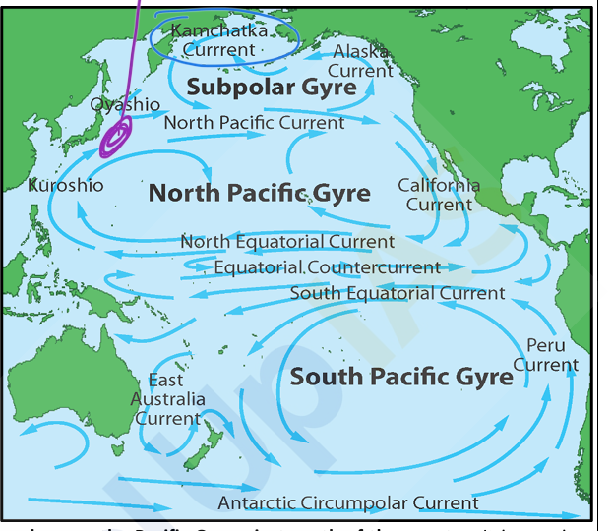
Warm Currents
- North Equatorial Current – Moves westward near the equator.
- South Equatorial Current – Similar to the North Equatorial Current, but in the Southern Hemisphere.
- Kuroshio Current (Japan Current) – A strong warm current flowing northward along Japan.
- East Australian Current – Flows southward along Australia's east coast.
- North Pacific Drift – Moves eastward toward North America.
Cold Currents
- Oyashio Current – A cold current from the Arctic, meeting the Kuroshio Current near Japan.
- California Current – A cold current flowing southward along the U.S. west coast.
- Peru (Humboldt) Current – Flows northward along the western coast of South America, supporting fisheries.

B. Atlantic Ocean Currents
Warm Currents
- North Equatorial Current – Flows westward from Africa toward the Caribbean.
- South Equatorial Current – Moves warm water westward to South America.
- Gulf Stream – A strong warm current flowing from the Gulf of Mexico to the North Atlantic. Florida current is continuation of gulf current shape accordingly Florida.
- Brazil Current – Moves southward along South America's east coast.
Cold Currents
- Canary Current – Moves southward along the northwest coast of Africa.
- Labrador Current – Flows southward from the Arctic, cooling Canada’s eastern coast.
- Falkland (Malvinas) Current – Cold current along South America’s southeastern coast.
- Benguela Current – Moves northward along Africa’s southwestern coast.

- 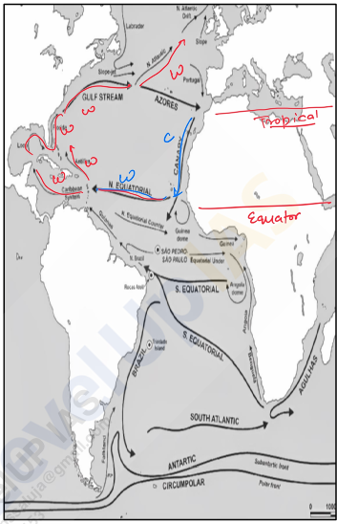

C. Indian Ocean Currents

Warm Currents
- North Equatorial Current – Moves westward near the equator.
- South Equatorial Current – Flows westward toward Africa.
- Mozambique Current – Flows southward of Mozambique east-coast.
- Madagascar Current – flows on west coast of Madagascar
  - North Madagascar current – flows on northwards
  - East Madagascar current – flows on southwards
- Agulhas Current – Moves warm water from the Indian Ocean to the Southern Ocean.
Cold Currents
- Somali Current – Reverses direction with monsoon seasons: Southwest Monsoon (summer) and flows northwards eastern coast of somalia.
  - During the Northeast Monsoon (winter), the current weakens and reverses direction, flowing southward as a warm current.
- West Australian Current (Leeuwin) – A cold current flowing northward along Australia’s west coast.
Drifts( seasonal ) special for Indian ocean.
Due to complex system of landmass distribution, earth’s rotation, seasonal winds.
    - Northeast Monsoon drifts:
Winter months November to February
blow from northeast towards westward.
    - Southwest monsoon drifts:
Summer month strongest in (June to September).
Flow from southwest and towards eastwards.

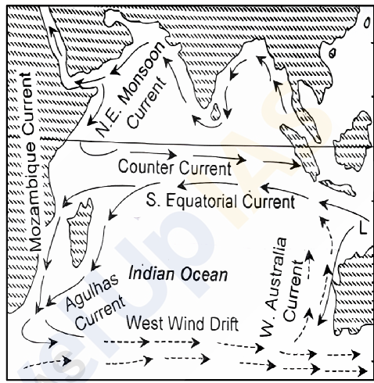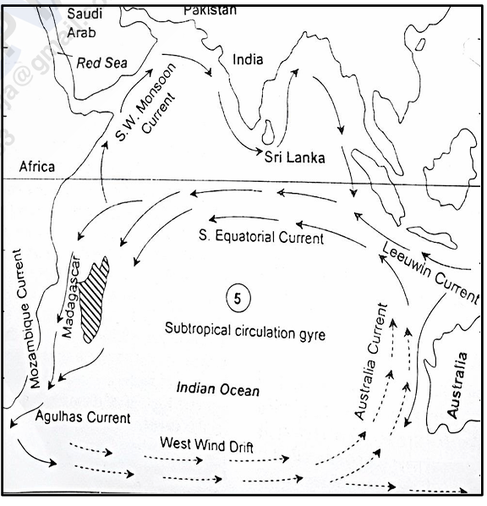

4. Effects of Ocean Currents
- Climate Regulation –
  - Warm currents cause warm wet climates.
    - (parallel to the east coasts of continents in tropical and subtropical latitudesclimates)
  - cold currents cause dry conditions/ moderate climate.
    - (western margins of subtropical anticyclones)
  - Foggy weather and drizzle: zone of warm and cold currents mix
- Desert Formation – Cold currents contribute to desertification along western tropical and subtropical continental coasts.
- Tropical Cyclones – Warm water currents fuel hurricanes and typhoons.
- Fishing Grounds – Areas where warm and cold currents mix (e.g., Grand Banks, Newfoundland) are rich in marine life.
- Navigation – Ships use ocean currents for faster travel.

OCEAN DEPOSITS AND THEIR CLASSIFICATION
1. Introduction
Ocean deposits are sediments that accumulate on the ocean floor due to various geological, biological, and atmospheric processes. These sediments provide valuable insights into Earth's climate history, ocean circulation, and marine ecosystems.
Sources of Ocean Deposits:
- Terrestrial Sources – Carried into the ocean by rivers, glaciers, wind, and coastal erosion.
- Volcanic Sources – Materials from underwater volcanic eruptions such as ash, pumice, and lava.
- Marine Organisms – shells Skeletal remains of microscopic plankton and marine creatures.
- Extraterrestrial Sources – Cosmic dust and micrometeorites from space.

2. Classification of Ocean Deposits
Ocean deposits are classified into two main types:
- Terrigenous Deposits (Derived from land-based sources, found near continents)
- Pelagic Deposits (Deep-sea sediments, formed away from land)

3. Terrigenous Deposits (Near Land Sediments)
Terrigenous deposits originate from continental sources and are transported to the ocean by rivers, glaciers, and winds. These deposits are found on the continental shelf, slope, and deep-sea basins.
Types of Terrigenous Deposits:
- Continental Shelf Deposits –
  - Found on continental shelves (shallow seabeds).
  - Includes sand, gravel, and silt carried by rivers and ocean currents.
- Continental Slope and Rise Deposits –
  - Found on the steep slopes between the continental shelf and deep ocean.
  - Composed of fine-grained sediments like mud and clay, transported by turbidity currents.

4. Pelagic Deposits (Deep Ocean Sediments)
Pelagic deposits accumulate in deep ocean basins, far from land. They are fine-grained and settle slowly over millions of years.
Types of Pelagic Deposits:
A. Pelagic Mud Deposits
- Red Clay –
  - Found in open ocean basins, far from land.
  - Composed of iron and manganese, giving it a reddish color.
- Abyssal Clay –
  - Forms at great depths due to the slow accumulation of fine particles.
B. Pelagic Biogenic Deposits (Ooze)
Ooze is a type of deep-sea sediment formed by the accumulation of microscopic marine organisms' remains.
- Siliceous Ooze –
  - Formed from the silica-rich skeletons of diatoms and radiolarians.
  - Found in nutrient-rich waters where plankton thrive.
- Calcareous Ooze –
  - Composed of calcium carbonate, from the remains of foraminifera and coccolithophores.
  - Found in shallower deep-sea regions, above the carbonate compensation depth (CCD).

5. Importance of Ocean Deposits
- Climate Change Indicators –
  - Provide evidence of past climate conditions, such as temperature and carbon levels.
- Oil and Gas Exploration –
  - Organic-rich sediments can convert into hydrocarbons (oil and gas) over millions of years.
- Marine Ecosystems –
  - Nutrient-rich sediments support deep-sea organisms.
- Scientific Research –
  - Help in understanding oceanic circulation, plate tectonics, and Earth's geological history.

SOIL AND ITS CLASSIFICATION
1. Introduction
- Soil is the uppermost layer of Earth's crust, formed over thousands of years through weathering processes.
- It consists of minerals, organic matter, air, and water.
- The texture of soil depends on the proportion of sand, silt, and clay it contains.
- Organic matter decomposes to form humus, which is essential for soil fertility.

2. Soil Genesis
- Pedology is the scientific study of soils.
- Pedogenesis refers to the process of soil formation.
- Soil acts as an interface between the atmosphere, lithosphere, hydrosphere, and biosphere.
- A vertical section of soil showing different layers is called a soil profile.

3. Soil Development
- Soil develops through weathering of parent rock and chemical & biological processes.
- The top layer of soil differs from lower layers due to higher biological activity.
- Soil is an essential medium for plant growth and ecosystem stability.

4. Soil Profile
Soil has distinct layers or horizons, which together form a soil profile:
- O Horizon (Organic Layer) – Contains decomposed leaves and organic matter (humus).
- A Horizon (Topsoil) – Rich in minerals and organic material, suitable for plant growth.
- E Horizon (Eluviated Layer) – Leached of clay, minerals, and organic matter.
- B Horizon (Subsoil) – Contains minerals leached from upper layers, rich in iron and clay.
- C Horizon (Parent Material) – Unconsolidated material from which soil develops.
- R Horizon (Bedrock) – Solid rock beneath the soil.

1. Eluviation
- Definition: The process of removal of fine particles, such as clay, silt, iron, and organic matter, from the upper layers (A and E horizons) of the soil.
- Mechanism:
  - Water leaches minerals and fine particles downward.
  - Leaves behind a lighter-colored, nutrient-depleted E horizon.
- Example:
  - Podzolization: In cold, humid regions, acidic water leaches iron and aluminium, forming podzolic soils.
  - Found in forest soils and older soils.

2. Cheluviation
- Definition: The process where organic acids from decaying plant material help dissolve and transport minerals (especially iron and aluminium) from upper to lower soil layers.
- Difference from Eluviation:
  - Cheluviation involves organic acids (chelates) that chemically bind with metals and move them downward.
- Example:
  - Common in coniferous forests, where needle litter produces organic acids.
  - Leads to iron and aluminium-rich B horizons in podzolic soils.

3. Illuviation
- Definition: The accumulation of minerals, clay, iron, aluminium, and organic matter in the lower B horizon after being transported from upper layers.
- Mechanism:
  - The particles removed via eluviation and cheluviation settle in the B horizon.
  - Forms dense, nutrient-rich subsoil.
- Example:
  - Hardpan formation in arid regions due to iron and clay accumulation.
  - Laterite soils form due to iron and aluminium deposition in tropical regions.

Comparison Table
Process | Movement | Horizon Affected | Material Transported | Example
Eluviation | Removal | A & E (upper layers) | Clay, silt, iron, organic matter | Leached E horizon in podzols
Cheluviation | Chemical removal via organic acids | A & E | Iron and aluminium | Acidic forest soils
Illuviation | Deposition | B (subsoil) | Clay, iron, aluminium | Hardpan, laterite soils

5. Soil-Forming Processes
Soil formation involves four key processes:
- Soil Enrichment – Addition of organic or inorganic matter (e.g., river floods deposit silt).
- Soil Removal – Loss of soil materials through erosion and leaching.
  - Cheluviation: downward movement of material due to organic agent.
- Soil Translocation – Movement of minerals and nutrients within soil layers.
  - Eluviation: Downward movement of fine particles.
  - Illuviation: Accumulation of minerals in the lower horizon.
- Soil Transformation – Alteration of minerals and decomposition of organic matter.

6. Soil-Forming Factors
- Climate – Influences soil moisture, organic matter decomposition, and mineral leaching.
- Organisms – Plants and animals contribute organic material and mix the soil.
- Relief (Topography) – Steep slopes lead to thin soils; valleys accumulate thick, fertile soils.
- Parent Material – Determines soil's mineral composition (e.g., basalt forms black soil).
- Time – Soil formation is a slow process, taking centuries for significant development.
- Human Activities – Deforestation, agriculture, and urbanization impact soil properties.

7. Classification of Soils in India
Soils in India are classified based on origin, color, composition, and location:
A. Alluvial Soil
- Formation: Deposited by rivers (Indus, Ganga, Brahmaputra).
- Characteristics:
  - Texture varies from sandy to clayey.
  - Rich in potash but poor in phosphorus.
  - High fertility, replenished by floods.
- Distribution: Northern Plains (Indo-Gangetic-Brahmaputra plane), coastal deltas (Mahanadi, Godavari, Krishna, Cauvery).
- Types:
  - Khadar (New Alluvium) – Found in floodplains, very fertile.
  - Bhangar (Old Alluvium) – Higher terraces with lime nodules (kankar{calcareous concentrations}).
  - Bhabar: pebbles rockdibries.
  - Tarai: poorely drain, marshy, thick forest narrowtrack.
- Agriculture: Supports rice, wheat, sugarcane, maize, and jute, oilseeds, vegetables, fruits.
B. Black Soil (Regur Soil)
- Formation: Derived from volcanic basaltic rock (Deccan Plateau).
- Characteristics:
  - Rich in clay, high moisture retention.
  - Contains iron, magnesium, lime, but low in phosphorus and nitrogen.
  - Cracks during dry seasons, improving aeration.
- Distribution: Maharashtra, Gujarat, Madhya Pradesh, Karnataka, Telangana, Tamil Nadu.
- Agriculture: Ideal for cotton, wheat, jowar, oilseeds, tobacco, and pulses.
C. Red Soil
- Formation: Formed from igneous and metamorphic rocks.
- Characteristics:
  - Rich in iron oxide, giving it a red colour.
  - Porous, loamy to sandy in texture.
  - Low in nitrogen, phosphorus, humus.
- Distribution: Tamil Nadu, Andhra Pradesh, Odisha, Madhya Pradesh, Karnataka.
- Agriculture: Rice, wheat, millets, pulses, sugarcane with added fertilizers.
D. Laterite Soil
- Formation: Intense leaching in tropical regions.
- Characteristics:
  - Rich in iron oxide, aluminium.
  - Poor in organic matter, nitrogen, phosphate.
  - Hardens irreversibly when dry.
- Distribution: Western Ghats, Eastern Ghats, parts of Chhattisgarh, Karnataka, Odisha.
- Agriculture: Used for tea, coffee, cashew, rubber, spices.
E. Arid Soil (Desert Soil)
- Formation: Formed in dry and semi-arid climates.
- Characteristics:
  - Sandy, porous, alkaline, poor in humus.
  - Contains kankar layer, reducing water infiltration.
- Distribution: Rajasthan, Gujarat, Punjab, Haryana.
- Agriculture: Supports bajra, pulses, guar with irrigation.
F. Forest Soil (Mountain Soil)
- Formation: Found in hilly and mountainous regions.
- Characteristics:
  - Silty, acidic, rich in humus.
  - Varies based on altitude and climate.
- Distribution: Himalayas, Western Ghats, Nilgiris, Annamalai hills.
- Agriculture: Used for tea, coffee, fruits, and spices.
G. Saline and Alkaline Soils
- Formation: Poor drainage leads to salt accumulation.
- Local name: Reh, Usar, Kallar, Rakar, Thur, and Chopan
- Characteristics:
  - High in sodium, potassium, magnesium.
  - Infertile but can be improved with gypsum and reduces salinity.
- Distribution: Western Gujarat, Punjab, Haryana, Rajasthan.
- Agriculture: Requires reclamation for crop cultivation.
H. Peaty and Marshy Soil (Bog Soil)
- Formation: Found in waterlogged areas with organic accumulation.
- Characteristics:
  - High moisture content, rich in humus.
  - Poor in potash and phosphate.
- Distribution: Sundarbans, Kerala backwaters, Almora (Uttarakhand).
- Agriculture: Used for jute, rice, spices, rubber.

8. Soil Problems and Conservation
A. Soil Problems
- Erosion (water, wind, glacial, human-induced).
- Degradation (chemical, physical, biological).
- Pollution (pesticides, industrial waste, urban waste, mining activity).
- Wrong agriculture practices (monoculture, overgrazing, over-irrigation, imper tillage)
- Soil Desertification: (drought, deforestation, wrong agriculture, climate change, overgrazing)
B. Soil Conservation Measures
- Afforestation, terracing, contour ploughing (perpendicular to flow), crop rotation, organic fertilizers, controlled grazing, mulching (strawberry farming),conservation tillage, soil reclamation(gypsum), pollution control

Soil Fertility in Different Soil Types
Soil fertility Soil Type | Nutrient Content | Water Retention | Aeration | Fertility | Best Crops
Alluvial Soil | Rich in potash but lacks phosphorus and nitrogen | High (due to silt & loam texture) | Good | Very fertile (due to flood replenishment) | Rice, wheat, sugarcane, maize, jute
Black Soil (Regur) | Rich in lime, iron, magnesium, but lacks phosphorus & nitrogen | Excellent (high clay content retains moisture) | Poor (sticky when wet, hard when dry) | Highly fertile, retains moisture for long periods | Cotton, wheat, pulses, oilseeds, sugarcane
Red Soil | Rich in iron oxide, but poor in nitrogen, phosphorus, and humus | Moderate | Good | Moderately fertile (can be improved with fertilizers) | Millets, pulses, rice (with irrigation)
Laterite Soil | Poor in organic matter, nitrogen, phosphate but rich in iron & aluminum oxides | Low (due to leaching) | Good | Infertile naturally, but can be improved with fertilizers | Cashew, coffee, tea, rubber, spices
Arid Soil (Desert Soil) | Deficient in humus, nitrogen, and phosphorus | Very low | High | Infertile, high salt content, requires irrigation | Bajra, pulses, guar (with irrigation)
Forest Soil (Mountain Soil) | Rich in humus, varies in mineral content | Moderate to high (varies with altitude) | Good | Moderately fertile in valleys, poor fertility in high altitudes | Tea, coffee, spices, fruits
Saline & Alkaline Soil | High in sodium, potassium, magnesium, but lacks essential nutrients | Poor | Poor | Infertile, high salinity hinders plant growth | Requires reclamation, supports salt-tolerant crops
Peaty & Marshy Soil (Bog Soil) | High in organic matter, but low in phosphate and potash | Very high | Poor (waterlogged) | Low fertility, high acidity | Jute, rice (if drained properly)

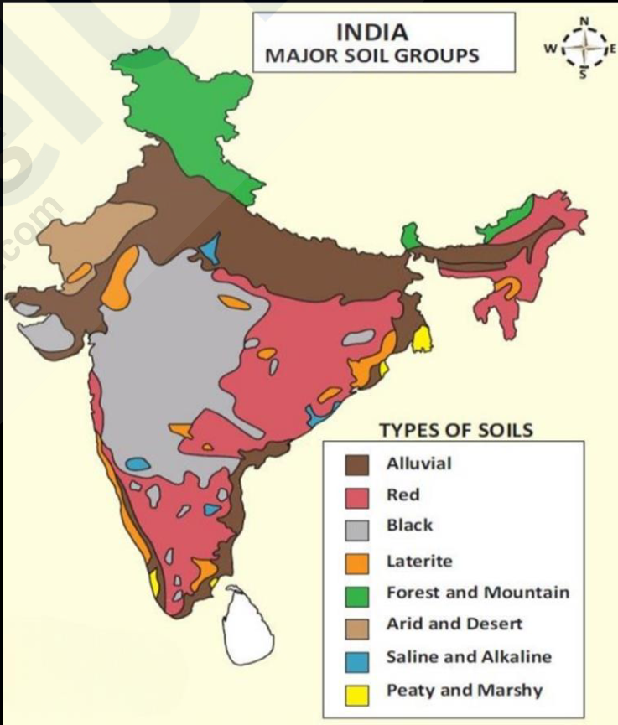

PHYSICAL SETTING OF INDIA
1. Introduction
- India is a country of immense geographical diversity, stretching from the Himalayas in the north to the Indian Ocean in the south.
- It forms part of South Asia and is separated from the rest of the continent by the Himalayas.
- The country exhibits varied landscapes, including mountains, plateaus, plains, deserts, and coastal regions.
- Due to its vast size and diversity, India is often referred to as a subcontinent.

2. Nomenclature of India
- India has been historically known by various names:
  - India: Derived from Greek literature, referring to the land of the Indoi (people near the Indus River).
  - Hindustan: Derived from the Persian adaptation of "Sindhu" (Indus River).
  - Bharat: Named after King Bharata, symbolizing national unity.
  - Aryavarta: Meaning the land of the Aryans, an ancient Sanskrit name.
- Today, India and Bharat are the official names of the country.

3. Location of India
- India lies entirely in the Northern Hemisphere.
- Latitudinal Extent: 8°4'N to 37°6'N
- Longitudinal Extent: 68°7'E to 97°25'E
- North-South Distance: 3,214 km
- East-West Distance: 2,933 km
- Northernmost Point: Indira Col, Ladakh
- Southernmost Point: Indira Point (Nicobar Islands)
- Westernmost Point: Ghuar Moti, Gujarat
- Easternmost Point: Kibithu, Arunachal Pradesh

4. Tropical and Subtropical Zones
- The Tropic of Cancer (23°30'N) passes through 8 states:
  - Gujarat, Rajasthan, Madhya Pradesh, Chhattisgarh, Jharkhand, West Bengal, Tripura, Mizoram.
- Southern India (below the Tropic of Cancer) lies in the Tropical Zone (hot and humid climate).
- Northern India (above the Tropic of Cancer) lies in the Subtropical Zone (moderate to extreme climate).

5. Peninsular Shape and Maritime Influence
- The Indian Peninsula is triangular, tapering towards the Indian Ocean.
- It divides the Indian Ocean into:
  - Arabian Sea (west)
  - Bay of Bengal (east)
- Total Coastline: 7,516.6 km (including islands).
- Palk Strait separates India from Sri Lanka.

6. Time Zone and Standard Time
- Due to its longitudinal extent, there is a two-hour time difference between eastern and western India.
- Time of day and night varies seasonally, max difference is at 5 hours in north most point and 45 minutes in south most point.
- Indian Standard Time (IST) is set at 82°30'E, passing through:
  - Uttar Pradesh, Madhya Pradesh, Chhattisgarh, Odisha, Andhra Pradesh.
- Need for Two Time Zones:
  - The northeast experiences sunrise earlier than western India.
  - Proposal: Divide India into IST-I (west) and IST-II (northeast) to improve productivity.

7. Size of India
- 7th largest country in the world (3.28 million sq. km).
- Land Boundary: 15,200 km
- Coastline: 7,516 km
- Strategic Location:
  - Central position in South Asia.
  - Historically connected through trade routes and mountain passes.

8. India and its Neighbours
India shares land borders with 7 countries:
- China (3,488 km)
- Pakistan (3,323 km)
- Bangladesh (4,096.7 km, longest)
- Nepal (1,751 km)
- Myanmar (1,643 km)
- Bhutan (699 km)
- Afghanistan (106 km, at PoK)
Border Disputes
- China: Aksai Chin (Ladakh) & Arunachal Pradesh (McMahon Line).
- Pakistan: Jammu & Kashmir, Sir Creek, Siachen Glacier.
- Nepal: Kalapani & Susta region.

9. Geological Structure of India
A. Introduction
- The geological structure determines soil, mineral resources, and water availability.
- India's geological history includes:
  - Formation of the Himalayas (Tertiary period).
  - Development of the Indo-Gangetic Plain (Pleistocene period).
  - Drifting of the Indian Plate (from Gondwanaland).

B. Geological Time Scale
- Standard Geological Time Scale (established in 1881).
- Indian Geological Time Scale (proposed by T.S. Holland).

C. Major Rock Systems in India
India’s geology is classified into four major rock systems:
1. Archaean Rock System (Pre-Cambrian Rocks)
- Oldest rocks (over 2.5 billion years old).
- Found in Peninsular India.
- Includes:
  - Archaean Gneisses & Granites (Basement Complex).
  - Dharwar System (rich in minerals like iron & manganese).
2. Purana Rock System
- Formed 1400-600 million years ago.
- Includes:
  - Cuddapah System (limestone, sandstone).
  - Vindhyan System (diamond-bearing, found in Panna, MP).
3. Dravidian Rock System (Palaeozoic Era, 600-300 million years ago)
- Found in the Himalayas and Gangetic Plain.
- Contains fossils.
- Includes Carboniferous Rocks (limestone, quartzite).
4. Aryan Rock System
- Formed after the Carboniferous period.
- Includes:
  - Gondwana System (rich in coal, 98% of India's reserves).
  - Jurassic System (found in Rajasthan, Kachchh).
  - Deccan Trap (volcanic basaltic lava, forms Black Soil).
  - Tertiary System (formation of the Himalayas).

10. Significance of India's Geology
- Himalayas: Young fold mountains, major rivers originate here.
- Indo-Gangetic Plain: Alluvial deposits, highly fertile.
- Peninsular Plateau: Oldest landmass, rich in minerals.
- Deserts: Thar Desert, formed due to climate conditions.
- Coastal Plains: Rich in marine resources.

Conclusion
India's geographical diversity and geological history play a crucial role in its climate, natural resources, and development. Understanding these aspects helps in planning agriculture, industry, and infrastructure for sustainable growth.

PHYSICAL SETTING OF INDIA – II
1. Introduction to Physiography
- Physiography is the study of Earth’s landforms, including mountains, plateaus, plains, valleys, and coastal areas.
- India’s diverse landscape has been shaped by geological processes over millions of years.
- The endogenic (internal) and exogenic (external) forces have played a significant role in shaping the current relief features of India.
- The physiography of India can be divided into five major divisions:
  - The Himalayan Mountains
  - The Great Plains of North India
  - The Peninsular Plateau
  - The Coastal Plains
  - The Islands

2. The Himalayan Mountains
- The Himalayas, also known as Himadri or Himavan, are young fold mountains formed due to the collision of the Indian and Eurasian plates.
- They extend 2,400 km from Jammu & Kashmir to Arunachal Pradesh.
- Width: 500 km (Kashmir) to 200 km (Arunachal Pradesh)
- Total Area: 500,000 sq km
- Highest peaks: 14 peaks above 8,000m, including Mt. Everest (8,848m), Kanchenjunga (8,586m), and Nanda Devi (7,816m).
3. Origin of the Himalayas
- The Tethys Sea existed between the Indian Plate and the Eurasian Plate.
- About 100 million years ago, the Indian Plate moved northward, colliding with the Eurasian Plate.
- This resulted in folding, faulting, and uplift, forming the Himalayan range.
- Even today, the Himalayas are rising due to active tectonic movements.
4. Phases of Himalayan Formation
The formation of the Himalayas occurred in six major phases:
- Plate Movement and Reunion Hotspot (100 million years ago) – The Indian Plate moved rapidly towards Eurasia.
- Himalayan Orogenesis (71 million years ago) – Collision between Indian and Eurasian plates.
- Drass Volcanic Arc Formation (Oligocene Epoch) – Volcanic activity along the collision zone.
- Greater Himalayas Uplift (30-35 million years ago) – Main Central Thrust (MCT) uplifted the Great Himalayas.
- Lesser Himalayas Formation (15-20 million years ago) – Formation of the Middle Himalayas along the Main Boundary Thrust (MBT).
- Rise of the Shiwalik Ranges – Formation of the outermost Himalayan range.
Evidence of Ongoing Himalayan Uplift
- Frequent earthquakes due to plate movements.
- Marine fossils found at high altitudes, indicating previous submersion.
- Rejuvenation of rivers due to rising land.
- Satellite and trigonometrical measurements show the Himalayas are rising 5-10 cm per year.

5. Division of the Himalayas
The Himalayas can be divided into:
A. The Himalayan Ranges
- The Great Himalayas (Himadri) – The highest and most continuous range (e.g., Everest, Kanchenjunga).
- The Lesser Himalayas (Himachal) – Middle Himalayas with peaks ranging 3,500-4,500m (e.g., Pir Panjal, Dhauladhar).
- The Shiwalik Range – Outer Himalayas, composed of unconsolidated sediments (e.g., Dehra Dun Valley).
B. The Trans-Himalayas
Located north of the Great Himalayas, includes:
- Karakoram Range (K2, 8,611m)
- Ladakh Range
- Zaskar Range
- Kailas Range
C. The Eastern Hills (Purvanchal)
- Extends into Arunachal Pradesh, Nagaland, Manipur, Mizoram.
- Includes Patkai Hills, Naga Hills, Manipur Hills, Lushai Hills.

6. Regional Division of the Himalayas
- Punjab Himalayas (Indus-Satluj) – Includes Pir Panjal, Ladakh, Zaskar ranges.
- Kumaon Himalayas (Satluj-Kali) – Includes Nanda Devi, Kamet, Kedarnath peaks, Trisul Bhadrinath, Kedarnath, Gangotri.
- Nepal Himalayas (Kali-Tista) – Home to Everest, Kanchenjunga, Dhaulagiri, Annapurna.
- Assam Himalayas (Tista-Brahmaputra) – Includes Namcha Barwa, kula kangri, chomo lhari.

The Significance of the Himalayas:
- Climatic Influence:
  - strategic orientation block the summer monsoons from the Bay of Bengal and the Arabian Sea, causing precipitation in the form of rain or snow
  - Without the Himalayas, India would be a dry desert with harsh winters
- Natural Defense:
  - Historically natural defense barrier, protecting from invasion
  - In 1962 natural shield in modern warfare
- Source of river
  - large glaciers and snowfields serve as feeding grounds for these rivers. rivers flow throughout year
  - Saluja, Beas, Ravi, Chenab, and Jhelum
  - Yamuna, Gomati, Ghaghara, Gandak, Kosi, Ram Ganga, Sarda
- Fertile Soil:
  - rivers descending from the Himalayas carry enormous quantities of alluvial soil. fertile plains of northern India are often referred to as the "Gift of the Himalayas."
- Hydroelectric Power Potential
  - natural waterfalls and suitable locations for dam construction.
  - potential for hydropower which is largely untaped.
- Rich Forest Resources
  - The Himalayas are home to diverse forests, ranging from tropical to alpine vegetation due to the varying altitudes.
  - fuelwood, timber, and raw materials for forest-based industries.
  - medicinal plants
- Agricultural Resources
  - Rice is dominant, maize, potatoes, tobacco, and ginger. Tea is unique.
  - apples, pears, grapes, walnuts, mulberries, and cherries.
- Tourism
  - Srinagar, Shimla, Manali, Mussoorie, Nainital, Darjeeling, and Gangtok.
- Pilgrimage Sites
  - Kailash, Amarnath, Badrinath, Kedarnath, Vaishno Devi, Gangotri, and Yamamori, often trekking
- Mineral Wealth
  - coal, copper, lead, zinc, nickel, cobalt, tungsten, silver, and limestone
  - potential reserves of petroleum in the tertiary rocks
7. The Great Plains of North India
- The Great Plains extend from Punjab to Assam, covering 780,000 sq. km.
- Formed by the Indus, Ganga, and Brahmaputra rivers.
- Highly fertile and densely populated.
Subdivisions
- Bhabar – Narrow belt of coarse sediments along the Shiwaliks.
- Tarai – Marshy region south of Bhabar, with high groundwater.
- Bhangar – Older alluvial deposits, rich in kankar nodules.
- Khadar – Newer floodplain deposits, highly fertile.
Regional Divisions
- Rajasthan Plain – desert proper, called Marusthali, Includes the Thar Desert, Luni River Basin, Sambhar Salt Lake. Didwana, Degana, Kuchaman, Sargol, and Khatu lakes
- Punjab-Haryana Plain – Land of five rivers(Satluj, Beas, Ravi, Chenab, and Jhelum), highly fertile doabs. The Ghaggar River is considered the modern-day successor of the legendary Saraswati River.
- Ganga Plain – Divided into Upper, Middle, and Lower Ganga Plains.
  - Yamuna, Gomati, Ghaghara, Gandak, Kosi
  - Upper ganga plain: Yamuna, Gomati, Ghaghara, Gandak, Kosi rivers. Western Ganga-Yamuna Doab, Rohilkhand and Avadh plain east
  - Middle ganga plain: Ghaghara, Gandak, and Kosi rivers, Ganga-Ghaghara doab, Ghaghara-Gandak doab, and Gandak-Kosi doab.
    - Son River flows from the south with a steeper gradient, leading to the Magadh Plain east of the Son.
  - Lower Ganga Plain: Bihar, West Bengal, and most of Bangladesh
    - Tista, Jal Dhaka, and Trosa rivers.
    - estuaries, mangroves, and tidal forests, known as the Sundarbans due to the Sundri tree.
- Brahmaputra Plain – Flood-prone, home to the Sundarbans delta.
  - Brahmaputra Valley, Assam Valley, or Assam Plain
  - Patkai and Naga Hills to the east. Garo, Khasi, Jaintia, and Mikir Hills to the south.

8. Significance of the Great Plain of North India
- Agriculture – Highly fertile, supports wheat, rice, sugarcane.
- Transport – Flat terrain allows dense road & rail network.
- Population Density – Home to major cities (Delhi, Kolkata, Patna).
- Economic Importance – Hub of industries, trade, and irrigation.
- Cultural and Political Centre – Delhi, the capital, is located here.

Conclusion
India’s physiographic diversity influences its climate, economy, agriculture, and settlement patterns. Understanding the Himalayas, Indo-Gangetic Plains, and their geological formations is essential for sustainable development, disaster management, and natural resource planning.

The Peninsular Plateau
The Peninsular Plateau is a vast triangular landmass in India, spanning 1,600 km north-south and 1,400 km east-west, covering 1.6 million sq km—half of India’s land area. Its base lies along the Great Plain of North India, with its apex at Kanyakumari. Bounded by the Aravalli, Vindhya, Satpura, Western Ghats, and Eastern Ghats, it has an average elevation of 600-900 m, sloping west to east except for the Narmada-Tapi Rift. Composed of Archean gneisses and schists, it’s a stable shield with minimal geological changes, featuring diverse plateaus, hills, and river basins.
The Plateaus of Peninsular India
- Central Highland: Known as Madhya Bharat Pathar, east of Marwar Upland, it includes the Chambal River basin with rift valleys, rolling terrain, forests, and northern badlands.
- Chotanagpur Plateau: Covers 87,000 sq km in Jharkhand, Chhattisgarh, and West Bengal, with 700 m elevation, Gondwana rocks, and radial drainage (Damodar, Subarnarekha, Koel).
- Deccan Plateau: Largest unit (5 lakh sq km), bordered by Satpura, Vindhya, and Ghats Mahadev and Maikal range, drained by Mahanadi, Godavari, Krishna, and Cauvery. Sub-regions:
  - Maharashtra Plateau (basaltic, black soil)( Godavari, Bhima, and Krishna Rivers.),
  - Karnataka Plateau (600-900 m, Malnad/Maidan),
  - Telangana Plateau (500-600 m, Archaean gneisses)( Godavari, Krishna, and Penneru Rivers.).
- Marwar Upland: East of Aravali (250-500 m), with Vindhyan rocks and Banas River erosion.
  - (sandstone, shales, and limestones rocks)
- Bundelkhand Upland: South of Yamuna (300-600 m), granite/gneiss, unfit for cultivation due to gorges created by Betwa, Dhasan, and Ken Rivers.
- Baghelkhand Plateau: East of Maikal (150-1,200 m), limestone/sandstone west, granite east, divides Son/Mahanadi systems.
- Malwa Plateau: Triangular, 1,50,000 sq km, lava flows, black soil, drained by Narmada, Tapi, Chambal, with northern ravines.
  - Bay of Bengal (Chambal, Betwa).
  - Arabian Sea (Narmada, Tapi, Mahi)
- Meghalaya Plateau: 35,000 sq km, separated by Garo-Rajmahal Gap, with Shillong Peak (1,961 m). Archaean quartzites, shales, and schists.
  - Garo Hills, Khasi-Jaintia Hills, and Mikir Hills.
- Chhattisgarh Plain: Saucer-shaped, 250-330 m, drained by Mahanadi, with Cuddapah limestone/shales. Maikal Range and the Odisha Hills
Hill Ranges of the Peninsular Plateau
Lower than the Himalayas, these are mostly relic hills or horsts separating plateaus and valleys.
Hills of Peninsular India
- Aravali Range: 800 km, Delhi to Palanpur, oldest range (Archaean), 400-600 m average, peaks like Guru Sikhar (1,722 m). Uplifted 600-700 million years ago, eroded(stumps), re-uplifted in Mesozoic.
  - Passes (Barr, Pipli Ghat, Dewair, and Desuri,)
- Vindhyan Range: 1,200 km, Jobat(gujrat) to Sasaram(bihar), 300-650 m, sedimentary rocks, watershed for Ganga and South India rivers. Chambal, Betwa, and Ken rivers originate within 30 km of the Narmada River.
- Satpura Range: 900 km, Rajpipla to Maikala,Mahadev Hills, 900-1,000 m, highest peak Dhupgarh (1,350 m), a tectonic horst. seven mountain ranges with peaks Astamba Dongar (1,325 meters) and Amarkantak (1,127 meters)
- Western Ghats (Sahyadris): 1,600 km, Tapi to Kanyakumari, steep west, gentle east.
  - Northern (1,200 m, Kalasubai 1,646 m), Salher, Mahabaleshwar, Harishchandragarh
  - Middle (1,200 m, Vavul Mala 2,339 m, Nilgiri junction), Kudremukh, Pushpagiri, Nilgiri Hills, which join the Sahyadris near Gudalur. Significant peaks include Doda Betta (2,637 m) and Makurti (2,554 m). sediments granites and gneisses.
  - Southern (Palghat Gap, Anai Mudi 2,695 m).
    - Anaimalai Range (1,800-2,000 m) to the north
    - Palni Hills (900-1,200 m) to the north-east
    - Cardamom Hills or Ealaimalai to the south
- Eastern Ghats: Fragmented due to Mahanadi, Godavari, ranges from Mahanadi to Vagai rivers.
  - Northern (900-1,400 m, Mahendra Giri 1,501 m), Madugula Konda Range
  - Southern (600-1,000 m, Nallamalai (Palkodna) Range).
  - Javadi, Shevroy-Kalrayan Hills
Significance of the Peninsular Plateau
- Geological: Precambrian rocks, insights into India’s history.
- Minerals: Coal, iron, manganese, bauxite, mica, limestone.
- Industry: steel, cement, aluminium in Jharkhand, Orissa, Chhattisgarh.
- Agriculture: Black soil for cotton, millets, pulses.
- Hydroelectric: Steep river gradients (e.g., Nagarjuna Sagar).
- Biodiversity: Forests, Western Ghats hotspot.
- Climate: Monsoon barrier, rainfall distribution.
- Cultural: Ancient kingdoms, historical sites.
- Tourism: Hill stations (Ooty), heritage (Hampi).
- Industry: Mineral-based steel, cement production. iron, steel, aluminium
The Coastal Plains
Extending 6,000 km, split into West (narrow, Western Ghats to Arabian Sea) and East (broader, Eastern Ghats to Bay of Bengal), meeting at Kanyakumari.
The West Coastal Plains
65 km average width, from Rann of Kachchh to Kanyakumari.
- Kachchh Peninsula: Former island, arid, sediment-filled,coastal sand dunes, sandy plain, rocky hill.
- Great/Little Rann: Salt plains, Great Rann 21,500 sq km.
- Kathiawar Peninsula: <200 m, Mt. Girnar (1,117 m), Gir lions. Mandev hill is highest point.
- Gujarat Plain: <150 m, fertile east, saline west. Narmada mahi, Sabarmati Tapi rivers.
- Konkan Plain: 500 km, 50-80 km wide, marine erosion, Mumbai reclaimed.
- Karnataka Coastal Plain: 225 km, 30-70 km wide, Jog Falls (271 m). Saravati river
- Kerala Plain (Malabar): 500 km, up to 96 km wide, backwaters (locally called Kayals)(Vembanad Lake). Ponnani near triruvanantpurm.
The East Coastal Plains
120 km average width, Subarnarekha to Kanyakumari, delta-rich.
- Utkal Plain: 400 km, Mahanadi Delta, Chilka Lake (780-1,144 sq km).
- Andhra Plain: Up to Pulicat Lake, Godavari-Krishna deltas (kolleru lake), Srihari Kota(isro). Harbours(Vishakhapatnam ,Machilipatnam)
- Tamil Nadu Plain: 675 km, 100 km wide, Cauvery Delta (130 km)(granary of south india).
Significance of the Coastal Plains
- Economic: Agriculture (rice), fishing, ports (Mumbai).
- Biodiversity: Mangroves, wetlands.
- Resources: Salt, oil, seafood.
- Climate: Moderates temperature, monsoon influence.
- Tourism: Beaches, heritage.
The Indian Islands
1,382 islands, key groups: Andaman-Nicobar (Bay of Bengal), Lakshadweep (Arabian Sea).
Andaman and Nicobar Islands
265 islands, 590 km, 6°45’N-13°45’N, tectonic origin. Duncan Passage, Ten Degree Channel separate groups. Port Blair (capital), Great Nicobar (largest), Saddle Peak (737 m). Volcanic (Barren, Narcondam), coral reefs, rainforests, seismic zone. Home to Sentinelese, dugong.
- Ritchie’s Archipelago: Neil (Shaheed Dweep), Havelock (Swaraj Dweep), Ross (Netaji Subhas Chandra Bose Dweep).
Lakshadweep Islands
36 coral islands, 32 sq km, 8°N-12°N, Reunion Hotspot. Kavaratti (capital),12 atolls, 3 reef, 5 submerge banks. 10 inhabited, Minicoy (largest). Fishing-based, low elevation (<5 m), vulnerable to sea-level rise. Pitti Island: turtle/bird breeding.
Significance of the Islands of India
- Biodiversity: Coral reefs, mangroves, conservation.
- Economic: Tourism, fisheries, coconut farming.
- Strategic: Shipping routes, naval outposts.
- Cultural: Indigenous tribes, tourism.
- Environmental: Climate change risks, sustainability.
- Research: Marine biology, conservation.
- Connectivity: Infrastructure boosts trade, tourism.

The Peninsular Plateau
The Peninsular Plateau is one of the major physiographic divisions of India, characterized by its ancient crystalline rock formations, rugged terrain, and varied topography. It is an extensive tableland that represents one of the oldest landmasses on Earth.
1. Introduction
- The Peninsular Plateau is a large plateau in India, extending from the south of the Indo-Gangetic Plain to the southern tip of the Indian subcontinent.
- It is primarily composed of igneous and metamorphic rocks of the Precambrian era.
- The plateau is bounded by the Western Ghats, Eastern Ghats, Aravalli Hills, and Satpura Range.
- It is divided into several smaller plateaus based on geography and geological structure.
2. Geographical Extent and Boundaries
- The plateau extends from the Vindhya and Satpura ranges in the north to Kanyakumari in the south.
- It is flanked by the Western Ghats on the west and the Eastern Ghats on the east.
- The plateau is broadly divided into two parts:
  - Central Highlands (northern part)
  - Deccan Plateau (southern part)
3. Geological Structure
- The Peninsular Plateau is one of the oldest landforms, formed by the break-up of the Gondwana landmass.
- It is composed mainly of crystalline rocks such as granite and gneiss.
- It is tectonically stable and has undergone minimal folding and faulting in recent times.
4. Major Divisions of the Peninsular Plateau
4.1 The Central Highlands
- Lies to the north of the Narmada River.
- Includes:
  - Malwa Plateau (in Madhya Pradesh)
  - Bundelkhand Plateau (in Uttar Pradesh and Madhya Pradesh)
  - Baghelkhand Plateau (in Madhya Pradesh and Chhattisgarh)
  - Chotanagpur Plateau (in Jharkhand, Odisha, and West Bengal)
- Drained by rivers like the Chambal, Betwa, and Son.
4.2 The Deccan Plateau
- Lies to the south of the Narmada River.
- Covers states like Maharashtra, Karnataka, Telangana, Andhra Pradesh, and Tamil Nadu.
- Includes:
  - Maharashtra Plateau: Godavari,bhima, krishna rivers
  - Karnataka Plateau:malnad hill, maidan
  - Telangana Plateau:peneru,Godavari,krishna rivers.
  - Andhra Plateau
- Drained by rivers like the Godavari, Krishna, and Kaveri.
5. Major Hill Ranges in the Peninsular Plateau
5.1 Aravalli Hills
- One of the oldest fold mountain ranges in the world.
- Runs from Gujarat to Delhi.
- Composed of metamorphic and igneous rocks.
- highest peak, Guru Sikhar, reaches 1,722 m and is located in Mt. Abu
5.2 Vindhya Range
- Acts as a geographical divide between North and South India.
- Runs parallel to the Narmada River.
- Bharner and Kaimur hills
5.3 Satpura Range
- Lies to the south of the Vindhyas.
- Forms the watershed between the Narmada and Tapi rivers.
- Rajpipla Hills in the west, Mahadev Hills, Maikala Range
5.4 Western Ghats
- Runs parallel to the western coast.
- Covers states like Maharashtra, Goa, Karnataka, and Kerala.
- Declared a UNESCO World Heritage site for its rich biodiversity.
- At southern side Nilgiris and Anamalai hills.
  - Northern western ghats: Kalasubai (1,646 m) , Salher (1,567 m) o Mahabaleshwar (1,438 m) , Harishchandra (1,424 m)
  - Passes: Thalghat,Bhorghat
  - Middle western ghats: Vavul Mala (2,339 m) , Kudremukh (1,892 m) ,Pushpagiri (1,714 m)
    - Nilgiris Hills (peaks Doda Betta (2,637 m) and Makurti (2,554 m).)is a junction for western and eastern ghat.
  - Southern western ghats: Palghat gap(mansoon in mysore region) peaks Anai Mudi (2,695 m),
    - Anaimalai Range (1,800-2,000 m) to the north
    - Palni Hills (900-1,200 m) to the north-east
    - Cardamom Hills or Elumalai to the south
5.5 Eastern Ghats
- Discontinuous range running along the eastern coast.
- Covers states like Odisha, Andhra Pradesh, and Tamil Nadu.
- Between Mahanadi River in Odisha to the Vagai River in Tamil Nadu
  - Northern eastern ghat: Mahendra Giri being the tallest at 1,501 meters. The Madugula Konda Range between Godavari and Mahanadi.
  - Southern eastern ghat: Nallamalai(Palkodna) Range,
    - Javadi Hills and Shevroy-Kalrayan Hills, Biligiri Rangan Hills

6. River Systems of the Peninsular Plateau
- Rivers are divided into two categories:
  - West-flowing rivers: Narmada, Tapi, Mandovi, and Zuari (drain into the Arabian Sea).
  - East-flowing rivers: Godavari, Krishna, Kaveri, and Mahanadi (drain into the Bay of Bengal).
- Rivers are mostly non-perennial except for a few like the Godavari and Krishna.
- Rivers form deltas before entering the sea.
7. Climate and Vegetation
- The plateau experiences a tropical monsoon climate.
- Western part receives heavy rainfall, while the interior regions are semi-arid.
- Vegetation varies from moist deciduous forests in the Western Ghats to dry deciduous and thorn forests in central and southern parts.
8. Economic Significance
8.1 Agriculture
- The plateau is fertile and supports crops like millets, pulses, cotton, and oilseeds.
- Black soil (Regur) is ideal for cotton cultivation.
8.2 Mineral Resources
- Rich in minerals like iron ore, manganese, coal, bauxite, and gold.
- Chotanagpur Plateau is the mineral heartland of India.
8.3 Industries
- Presence of mineral-based industries like iron and steel, cement, and aluminum.
- IT and automobile hubs in Bengaluru, Hyderabad, and Pune.
9. Conclusion
- The Peninsular Plateau is an ancient, stable landmass with significant economic and ecological importance.
- It plays a crucial role in India’s agriculture, mineral wealth, and industrial development.
- The plateau also hosts diverse ecosystems, making it a vital natural heritage of India.

Drainage System of India
Introduction to Drainage System
- The drainage system refers to the river systems that collect and direct rainwater.
- India has a complex drainage system influenced by geological and climatic factors.
- Drainage patterns depend on topography, rock structure, and climatic conditions.
Major River Systems in India
- The Himalayan Rivers
  - Perennial in nature
  - Originates from the Himalayas and flows towards the plains
  - Includes major rivers like the Ganga, Indus, and Brahmaputra
- The Peninsular Rivers
  - Non-perennial in nature
  - Dependent on monsoon rainfall
  - Includes major rivers like the Godavari, Krishna, and Kaveri
Classification of Drainage System
- On the Basis of Discharge of Water
  - Arabian Sea Drainage: 23% of India's drainage area,Rivers flowing westward into the Arabian Sea (e.g., Narmada, Tapi,Sabarmati, Mahi,indus)
  - Bay of Bengal Drainage: 77% of India's drainage area, Rivers flowing eastward into the Bay of Bengal (e.g., Ganga, Brahmaputra, Mahanadi, Godavari, Krishna, Cauvery, Penneru, Penneiyar, and Vaigai)
- On the Basis of Origin
  - Himalayan Rivers (Indus, Ganga, Brahmaputra)
  - Peninsular Rivers (Godavari, Krishna, Mahanadi, Cauvery, Narmada, and Tapi)
- On the Basis of Type of Flow
  - Perennial Rivers: Flow throughout the year (e.g., Ganga, Brahmaputra)
  - Seasonal Rivers: Flow only during monsoon (e.g., Peninsular Rivers)
- On the Basis of Drainage Pattern
  - Dendritic Pattern: Tributaries join larger streams at acute angles, Tree-like pattern, e.g., Ganga River system, Indus, Brahmaputra
  - Radial Pattern: Rivers radiate from a central point (conical landforms), e.g. in Amarkantak plateau Narmada and Son tributaries.
  - Trellis Pattern: (Synclines (down-turned folds)) primary tributaries flow Parallel streams with perpendicular secondary tributaries, e.g., Vindhyan range, upper Himalayan region like the Indus, Ganga, and Brahmaputra
  - Rectangular Pattern: joining the mainstream at high angles or Right-angle bends, e.g., Vindhya Mountain range, such as the Chambal, Betwa, and Ken.
- Based on Size of Catchment Area:
  - Major River Basins: Catchment area ≥ 20,000 sq km.
  - Medium River Basins: Catchment area between 2,000–20,000 sq km.
  - Minor River Basins: Catchment area < 2,000 sq km.
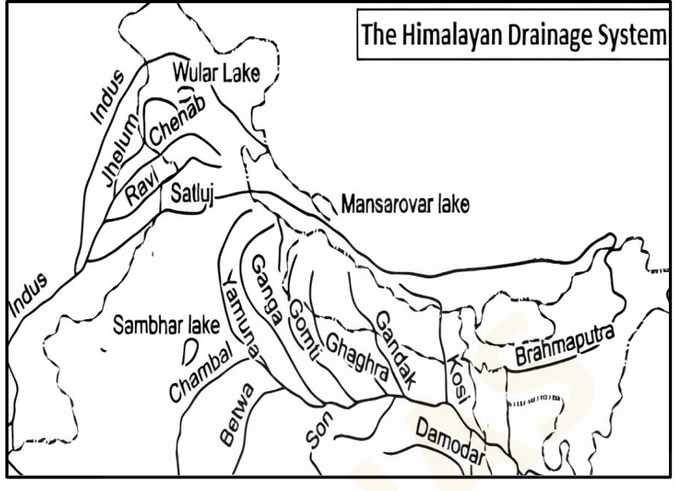
The Indus River System
- Originates from Tibet (Lake Mansarovar)
- Major tributaries: Jhelum, Chenab, Ravi, Beas, Sutlej
- Enters India in Ladakh and flows into Pakistan
The Ganga River System
- Originates from Gangotri Glacier in Uttarakhand
- Major tributaries: Yamuna, Ghaghara, Gandak, Kosi
- Forms the largest delta (Sundarbans) before meeting the Bay of Bengal
The Brahmaputra River System
- Originates from Tibet (Tsangpo River)
- Enters India in Arunachal Pradesh
- Flows through Assam and joins the Ganga
The Peninsular River Systems
- East-flowing Rivers
  - Godavari (Dakshina Ganga, longest Peninsular river)
  - Krishna
  - Mahanadi
  - Kaveri
- West-flowing Rivers
  - Narmada
  - Tapi
  - Mahi
  - Sabarmati
Importance of Rivers
- Irrigation and Agriculture
- Hydroelectric Power Generation
- Drinking Water Supply
- Inland Navigation
- Cultural and Religious Significance
River Pollution and Conservation
- Causes of River Pollution:
  - Industrial Waste
  - Domestic Sewage
  - Agricultural Runoff
- Measures for Conservation:
  - River Cleaning Projects (Namami Gange)
  - Afforestation
  - Waste Treatment Plants
Conclusion
- Rivers are the lifelines of India’s civilization.
- Proper management and conservation of rivers are necessary for sustainable development.

Drainage System
Introduction
- The drainage system refers to the network of rivers and streams that drain water from a region.
- India's drainage systems are shaped by its diverse topography, including the Himalayas and the Peninsular Plateau.
Some Important Concepts
- Drainage Patterns:
  - Rectangular Drainage Pattern: Found in faulted regions with jointed rocky terrain; streams follow weak rock paths, forming sharp bends and high-angle confluences (e.g., Chambal, Betwa, Ken in Vindhya Mountains).
  - Radial Drainage Pattern: Develops around a central elevated point (e.g., volcanoes); rivers flow outward in all directions (e.g., Narmada and Son from Amarkantak range).
  - Centripetal Drainage Pattern: Streams flow toward a central depression, forming temporary lakes that dry up, leaving salt flats (e.g., Loktak Lake, Manipur).
  - Dendritic Pattern: Tributaries join larger streams at acute angles, Tree-like pattern, e.g., Ganga River system, Indus, Brahmaputra
  - Trellis Pattern: (Synclines (down-turned folds)) primary tributaries flow Parallel streams with perpendicular secondary tributaries, e.g., Vindhyan range, upper Himalayan region like the Indus, Ganga, and Brahmaputra

Classification of Drainage Systems of India
- Based on Size of Catchment Area:
  - Major River Basins: Catchment area ≥ 20,000 sq km.
  - Medium River Basins: Catchment area between 2,000–20,000 sq km.
  - Minor River Basins: Catchment area < 2,000 sq km.
- Based on Origin:
  - Himalayan Rivers: Indus, Ganga, Brahmaputra, and tributaries.
  - Peninsular Rivers: Mahanadi, Godavari, Krishna, Cauvery, Narmada, Tapi, and tributaries.
- Based on Orientation to the Sea:
  - Bay of Bengal Drainage: Covers 77% of India’s drainage area; includes Ganga, Brahmaputra, Mahanadi, Godavari, Krishna, Cauvery, Penneru, Penneiyar, Vaigai.
  - Arabian Sea Drainage: Covers 23% of India’s drainage area; includes Indus, Narmada, Tapi, Sabarmati, Mahi, and swift rivers from the Sahyadri Range.
- Based on Size of Catchment Area:
  - Major River Basins: Catchment area ≥ 20,000 sq km.
  - Medium River Basins: Catchment area between 2,000–20,000 sq km.
  - Minor River Basins: Catchment area < 2,000 sq km.
- Key Fact: Over 90% of India’s river water flows into the Bay of Bengal, with the rest into the Arabian Sea or inland drainage, due to a 2,736 km watershed from Kanyakumari to Haridwar.

The Himalayan Drainage System
- Comprises Ganga, Indus, and Brahmaputra basins; perennial due to snowmelt and rainfall.
- Features deep gorges in mountains, depositional features (flat valleys, ox-bow lakes, flood plains, braided channels, deltas) in plains.
- Rivers shift courses in plains (e.g., Kosi River, "Sorrow of Bihar," due to sediment deposition).
Evolution of the Himalayan Drainage
- Theory: A mighty Shiwalik or Indo-Brahma River flowed from Assam to Punjab during the Miocene (5–24 million years ago), later dismembered into:
  - Indus (west)
  - Ganga (central)
  - Brahmaputra (east)
- Causes:
  - Pleistocene upheaval in western Himalayas (uplift of Potwar Plateau/Delhi Ridge) separated Indus and Ganga.
  - Down-thrusting of Malda gap diverted Ganga and Brahmaputra to the Bay of Bengal.

The Indus River System
- One of the largest drainage systems globally; gave India its name (Sanskrit: Sindhu).
- Linked to the Indus Valley Civilization.
- Tributaries Gilgit, Gortang, Dras, Shiger, and Hunza Rivers.
Origin and Course of the Indus River
- Origin: Kailas Range glaciers near Mansarovar Lake, Tibet (5,182 m; 31°15’N, 81°40’E).
- Course:
  - Flows 257 km northwest in Tibet (Singge Khabab), joined by Dhar River.
  - Enters India at 4,206 m, flows between Ladakh and Zaskar Ranges (gentle gradient: 30 cm/km).
  - Joins Zaskar near Leh, Shyok near Skardu (2,700 m), cuts 5,181 m gorge near Bunji.
  - Bends south at Attock (610 m), joined by Kabul River; flows through Potwar Plain, Salt Range.
  - Meets Panjnad (five eastern tributaries) at Mithankot (79 m), forms a delta south of Karachi into the Arabian Sea.
- Total Length: 2,880 km (709 km in India).
- Annual Flow: 110,450 million cubic meters at Kalabagh.
Major Tributaries of the Indus River System
- Jhelum River: (originate in Verinag in Kashmir valley).
  - Pir Panjal Range near Baramula.
  - flowing northwards to Wular Lake then southwards.
  - Tributaries Lidar, Sind, and Pohru Rivers join it in Kashmir. Other tributary Kishanganga River on its right bank.
  - Joins Chenab River at Trimmu.
- Chenab(Chandrabhaga):
  - originates near the Bara Lacha Pass in the Lahul-Spiti region
  - two streams Chandra and Bhaga join at Tandi.
  - Right tributary Jhelum and left tributary Ravi.
  - Satluj River at Panchnad
- Ravi:
  - Originate Kullu Hills near the Rohtang Pass in Himachal Pradesh
  - joining the Chenab River near Rangpur.
- Beas
  - originates near the Rohtang Pass in Himachal Pradesh
  - joining the Satluj River at Harike in Punjab.
- Satluj:
  - Arised Manasarovar-Rakas Lakes in western Tibet.
  - Naina Devi Dhar (where the Bhakra Dam is located)
  - meets the Beas River at Harike.
  - Joint Indus at (Panjnad).
- Other tributaries: Jhelum, Chenab, Ravi, Beas, Satluj (Panjnad).

The Ganga River System
- Central Himalayan drainage system; sacred and vital for northern India.
Origin and Course of the Ganga
- Origin: Bhagirathi River from Gangotri Glacier (Uttarakhand); joins Alaknanda at Devprayag to form Ganga.
- Course:
  - Flows through Himalayas, enters plains at Haridwar.
  - Meanders across Gangetic Plains, joined by numerous tributaries.
  - Forms a massive delta with Brahmaputra in Bangladesh, emptying into the Bay of Bengal.
- Length: Approximately 2,525 km.
Major Tributaries of the Ganga River System
- Yamuna River: (Details incomplete; typically originates at Yamunotri, joins Ganga at Allahabad/Prayagraj).
  - traversing the Nag Tibba, Mussoorie, and Shiwalik ranges.
  - Streams Rishiganga, Uma, and Hanuman Ganga, join the Yamuna.
  - Tributary Rivers: Hindon. (Peninsular platue) Chambal, Sind, Betwa, and Ken.
  - Chambal rivers:
    - Originate highlands of Janapao Hills in Vindhya Range of Madhya Pradesh.
    - Travel through Kota and join in Etawah district to Yamuna.
    - Tributary : Banas, Sind rivers.
  - Betwa river:
    - Originate Bhopal district and joins the Yamuna near Hamirpur.
    - Tributaries: Halali and Dhasan River.
  - Ken river:
    - Originate at Barner Range of Madhya Pradesh, joins the Yamuna near Chila
- Son river:
  - Originate from Amarkantak Plateau, located near the source of the Narmada River
  - Son River merges with the Ganga at Danapur in Patana district.
  - Tributaries: Johilla, Gopat, Rihand, Kanhar, and North Koel
- Damodar river:
  - Originate at Chotanagpur Plateau. Due to floods it named “Sorrow of Bengal”
  - merges with the Hugli River.
- Ramganga rivers:
  - Originate Garhwal district of Uttarakhand.
  - joining the Ganga at Kannauj.
  - Tributaries: Khoh, Gangan, Aril, Kosi, and the Deoha (Gorra)
- Ghaghara River:
  - Origin: Tibet/Nepal Himalayas(Gurla Mandhata peak,mansarovar)
  - Course: Enters India, flows 425 km, joins Ganga at Hajipur, Bihar.
  - Drainage Area: 46,300 sq km (7,620 sq km in India).
  - Annual Flow: 52,200 million cubic meters.
  - Tributaries: Kali Gandak, Mayangadi, Bari, Trishuli. Sarda, Sarju (on whose banks Ayodhya is located), and the Rapti.
  - Ghaghra joins the Ganga a few kilometers downstream of Chhapra in Bihar.
  - Kali river:
    - Originates high glaciers of the trans-Himalaya
    - The Kali takes a southeasterly course and eventually joins the Ghaghra
- Gandak reiver:
  - Originate at Tibet-Nepal border in Nepal Himalaya.
  - Tribeni and flows into the Ganga at Hajipur in Bihar.
- Burhi Gandak:
  - Origin: Sumesar Hills (India-Nepal border).
  - Course: Flows southeast, joins Ganga near Monghyr.
  - Length: 610 km; Drainage Area: 12,200 sq km.
- Kosi River ("Sorrow of Bihar"):
  - Origin: Seven streams (Sut Kosi, Tamba Kosi, Talkha, Doodh Kosi, Botia Kosi, Arun, Tamber) in eastern Nepal (Sapt Kaushik region).
  - Course: Arun (main tributary) from Gosainthan; merges into Tumar (44%), Arun (37%), Sun Kosi (19%) at Triveni; cuts Mahabharata Range gorge; flows 730 km in India, joins Ganga near Kursela.
  - Drainage Area: 86,900 sq km (21,500 sq km in India).
  - Features: Braided channel, frequent course shifts, devastating floods; barrage at Hanuman Nagar (1965) and embankments for flood control.

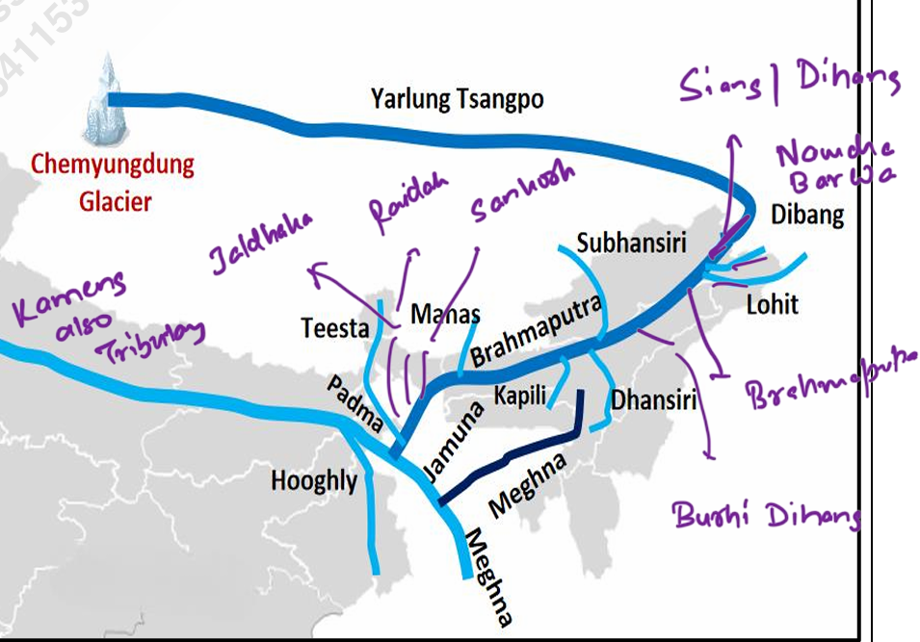
The Brahmaputra River System
- One of the world’s longest rivers (2,900 km), spanning Tibet, India, and Bangladesh.
Origin and Course in Tibet
- Origin: Chemayungdung Glacier, Kailas Range (5,150 m; 30°31’N, 82°10’E), near Indus and Satluj sources.
- Course:
  - Flows 1,800 km east as Tsangpo(Chinese name : Yarlung Zangbo Jiangin) in Tibet; gentle slope, navigable for 640 km.
  - Tributaries: Raga Tsangpo, Ngangchu, Kyichu (north); Griamda (east).
  - Turns northeast, then south through Dihang Gorge (5,485 m drop), enters India near Sadiya as Siang/Dihang.
Flow through Assam
- Course: Flows 720 km as Brahmaputra through Assam Valley; braided channel, frequent meanders, floods.
- Tributaries:
  - North: Subansiri, Kameng, Belsiri, Dhansiri (North), Nyera Ama, Manas, Champaman, Gangadhar, Raidah, Dharla, Tista (shifted from Ganga in 1787).
  - South: Dibru, Burhi Dihing, Noa Dihing, Dikhu, Dhansiri (South), Kalang.
- Features: 16 km wide at Dibrugarh; Majuli Island (90 km x 20 km, 1,250 sq km); navigable up to 1,384 km.
Flow through Bangladesh
- Course: Enters Bangladesh near Dhubri as Jamuna (270 km), joins Ganga at Goalundo (Padma), then Meghna River, forming an estuary into the Bay of Bengal.
Major Tributaries of the Brahmaputra River System
- Subansiri River: "Gold River"; flows through Lower Subansiri, Arunachal Pradesh; known for kayaking.
- Kameng River: Originates in Tawang, flows through Arunachal Pradesh and Assam; near Pakhui and Kaziranga parks.
- Manas River: Transboundary (376 km); 272 km in Bhutan, 104 km in Assam; joins at Jogighopa; near wildlife sanctuaries.
- Sankosh River: Originates in Bhutan; glaciated upper course, forested catchment; joins in Assam.
- Teesta River: Originates at Tso Lhamo Lake (5,330 m), Sikkim; joins via Rangeet at Tribeni; flows to Brahmaputra in Bangladesh.
- Dibang River: Originates near Tibet (5,000+ m); flows through Mishmi Hills, joins near Nizamghat.
- Lohit River: Originates in Tibet, flows through Mishmi Hills; joins Siang at Brahmaputra head.
- Dhansiri River: Main river in Golaghat (Assam) and Dimapur (Nagaland); linked to swampy areas.
- Kopili River: Interstate (Meghalaya-Assam); largest south bank tributary; threatened by mining and projects.
- Siyom River: Right-bank tributary from Assam Himalayas; near Mouling National Park; strategic Siyom Bridge.

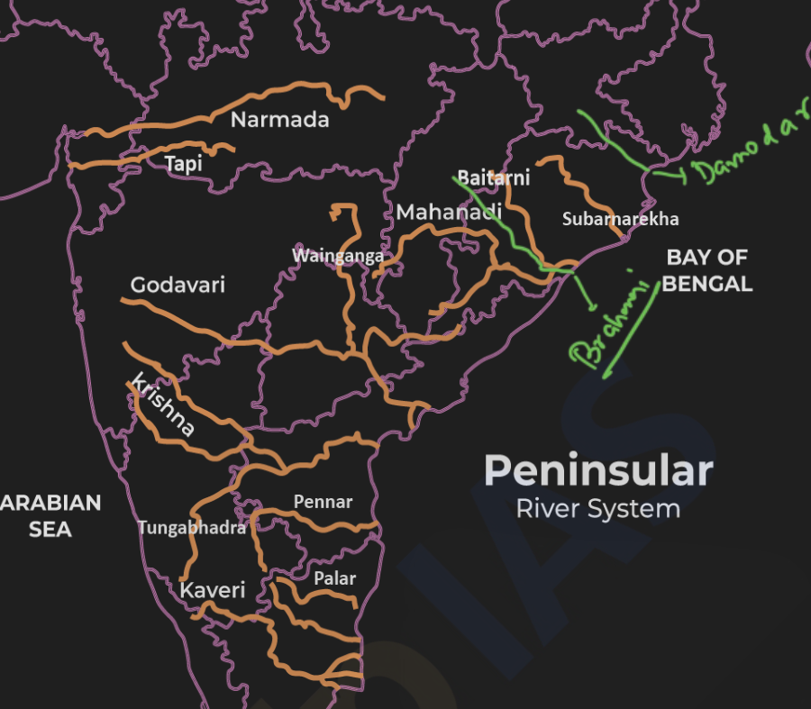
The Peninsular Drainage System
- Older than Himalayan rivers; mature stage with shallow, graded valleys; low gradient, reduced velocity, and load capacity.
- East-flowing rivers form deltas; west-flowing rivers (e.g., Narmada, Tapi) form estuaries; generally fixed courses, non-perennial (except Narmada, Tapi in rift valleys).
Evolution of the Peninsular Drainage
- Shaped by three geological events:
  - Subsidence of Western Flank: Early tertiary submergence disrupted symmetrical river arrangement.
  - Upheaval of Himalayas: Northern subsidence and trough faulting led to Narmada and Tapi flowing in rift valleys.
  - Tilting of Peninsular Block: Northwest-to-southeast tilt-oriented drainage toward the Bay of Bengal.

The East Flowing Rivers of Peninsular India
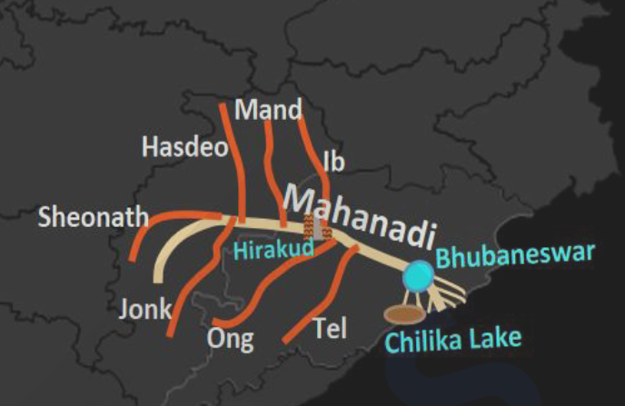
- Mahanadi River:
  - Origin: Dandakaranya foothills, Sihawa, Chhattisgarh (442 m).
  - Course: Flows northeast, then east and south; gorge at Tikkarpara; delta at Naraj; empties into Bay of Bengal (857 km).
  - Tributaries: Left (Ib, Mand, Hasdo, Sheonath); Right (Ong, Jonk, Tel).
  - Delta: 9,500 sq km, 150 km wide.
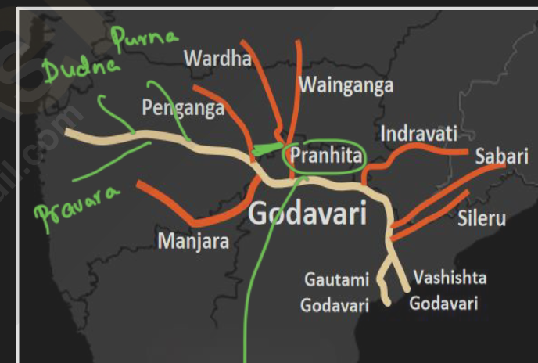
- Godavari River ("Vridha Ganga"/”Dakshin ganga”):
  - Origin: Trimbak Plateau, North Sahyadri, Maharashtra.
  - Course: Flows east (1,465 km); splits into Gautami and Vashishta at Rajahmundry; forms lobate delta into Bay of Bengal.
  - Tributaries: Right (Manjra); Left (Penganga {joins Wardha }, Wardha, Wainganga, Indravati, Sabari).
  - Features: 60 km gorge; delta front 120 km; navigable 300 km.
  - 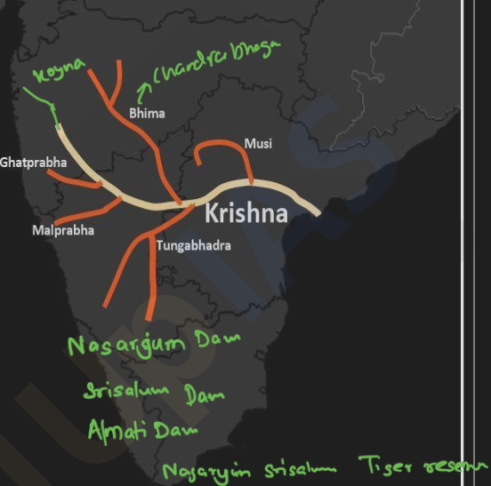
- Krishna River:
  - Origin: Western Ghats near Mahabaleshwar.
  - Course: Flows east (1,400 km); forms delta into Bay of Bengal.
  - Tributaries: Koyna, Ghataprabha, Malprabha, Bhima (with sub-tributaries Mula, Mutha, Ghod, Nora), Tungabhadra(Tunga and Bhadra rivers), Musi, Muneru.
  - Delta: 4,600 sq km, merges with Godavari’s.
  - 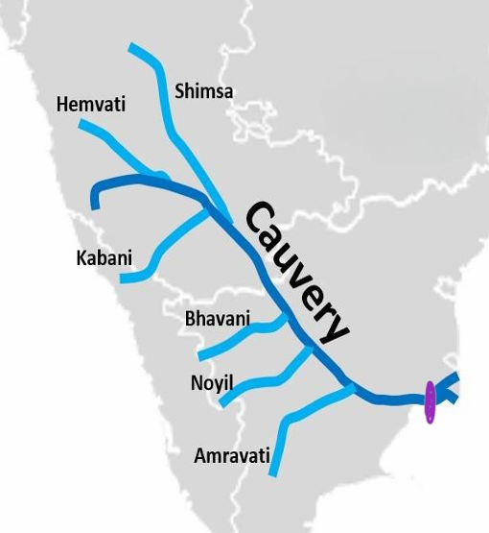
- Kaveri (Cauvery) River ("Dakshina Ganga/Ganga of the south"):
  - Origin: Taal Cauvery, Brahmagiri, Western Ghats (1,341 m).
  - Course: Flows east (800 km); splits into Kollidam and Cauvery at Srirangam; forms delta into Bay of Bengal.
  - Tributaries: North (Herangi, Hemavati, Lokpavani, Srimsha, Arkavati); South (Laksmantirtha, Kabani, Suvarnavati, Bhavani, Amravati).
  - Features: Perennial due to dual monsoons; Shivasamudram Falls (101 m); delta 8,000 sq km.
- Subarnarekha River: Originates at Ranchi Plateau (600 m); flows 395 km; forms estuary into Bay of Bengal.
- Brahmani River: Formed by Koel and Sankh rivers; flows 800 km; tributaries (Kura, Sankhad, Tikra); joins Mahanadi delta.
- Penneru River: Originates at Nandi Durg, Karnataka; flows 597 km; forms narrow estuary into Bay of Bengal.
- Ponnaiyar River: Small coastal stream south of Kaveri; Vaigai is longest in region.

The West Flowing Rivers of Peninsular India
- Fewer and smaller than east-flowing rivers; flow through fault planes, form estuaries due to hard rock terrain.
- Narmada River:
  - Origin: Amarkantak Plateau, Madhya Pradesh (1,057 m).
  - Course: Flows west (1,310 km) through rift valley; Dhuan Dhar Falls at Jabalpur; estuary into Gulf of Khambhat.
  - Waterfall: mandhar, dardi near Maheshwar. Shastradh ara.
  - Tributaries: Right (Hiran, Orsang, Barna, Kolar); Left (Burhner, Banjar, Shar, Shakkar, Tawa, Kundi).
  - Features: Marble Rocks; navigable 112 km.
- Tapi River( Tripti ):
  - Origin: Multai, Satpura Plateau (730 m).
  - Course: Flows west (730 km); estuary into Gulf of Khambhat.
  - Tributaries: Right (Betul, Patki, Ganjal, etc.); Left (Purna, Ambhora, Khursi, etc.).
  - Features: Tidal for 48 km; navigable 32 km.
- Sabarmati River: Originates in mewar Aravali Range; flows 320 km; empties into Gulf of Khambhat. Streams sabar, hathmati.
- Mahi River: Originates in Vindhyas (500 m); flows 533 km; empties into Gulf of Khambhat. Tributaries: son Anus panam.
- Luni River: Originates west of Ajmer (550 m); flows 482 km; vanishes in Rann of Kachchh; brackish below Balotra.

Differences between the Himalayan and the Peninsular River Systems
Aspect | Himalayan River System | Peninsular River System
Origin | Lofty Himalayan ranges | Peninsular Plateau
Catchment Area | Large basins (e.g., Indus: 11.78 lakh sq km) | Small basins (e.g., Godavari: 3.12 lakh sq km)
Valleys | Deep V-shaped gorges due to uplift and erosion | Shallow, graded valleys with little erosion
Drainage Type | Antecedent (pre-existing uplift) | Consequent (follows slope)
Water Flow | Perennial (snowmelt + monsoon); useful for irrigation | Seasonal (rainfall only); less useful for irrigation
Stage | Youthful stage, flowing through young mountains | Mature stage, flowing on ancient plateau
Meanders | Highly tortuous in mountains, meanders in plains | Straight courses due to hard rock
Deltas/Estuaries | Large deltas (e.g., Ganga-Brahmaputra) | Estuaries (Narmada, Tapi); some deltas (Godavari)

Detailed Notes on the Climate of India
1. Introduction to the Climate of India
- Definition: The climate of a country involves the study of long-term patterns of temperature, rainfall, atmospheric pressure, and wind direction and speed.
- Influencing Factors:
  - Latitudinal Extent: India's position between 8°N and 37°N influences its climatic zones.
  - Relief Features: The Himalayas and Western Ghats play significant roles in shaping weather patterns.
  - Land and Water Distribution: Proximity to the Arabian Sea, Bay of Bengal, and Indian Ocean affects climate.
- Key Features:
  - Tropic of Cancer: Divides India into tropical and subtropical zones, passing through its middle.
  - Himalayan Barrier: Prevents cold Central Asian air masses from entering, making northern India 3°C to 8°C warmer in winter than similar latitudes.
  - Southern Coastal Influence: The Arabian Sea and Bay of Bengal reinforce India’s tropical monsoon climate.
- Classification: India is a tropical monsoon country due to its distinct wet and dry seasons.

2. Unity and Diversity in the Indian Monsoon Climate
- Unity:
  - The monsoon regime unifies the climate of India and Southeast Asia, creating a broad climatic pattern.
- Diversity:
  - Regional variations exist in wind patterns, temperature, rainfall, seasonal rhythms, and dryness/wetness due to:
    - Location
    - Altitude
    - Distance from the sea
    - Relief features
  - Examples of Diversity:
    - Temperature Variation in Summer: June temperatures reach 48°C-50°C in Barmer, Rajasthan, but only 22°C in Gulmarg, Kashmir.
    - Temperature Variation in Winter: December nights drop to -40°C in Dras, Jammu and Kashmir, while Thiruvananthapuram stays at 20°C-22°C.
    - Rainfall Extremes: Mawsynram, Meghalaya, gets 1,221 cm annually (wettest place on Earth), while Jaisalmer, Rajasthan, receives less than 12 cm.
    - Monsoonal Storms: Frequent rainstorms (every 3-5 days) in the Ganga Delta and Odisha in July-August, while the Coromandel Coast remains dry, awaiting the northeast monsoon.
    - Coastal vs. Interior Climate: Mumbai and the Konkan Coast have mild climates, while Delhi and Agra face extreme summers and winters.
    - Arrival of Monsoon: Early June rains in Goa, Hyderabad, Bhubaneswar, and Patna, but late June/early July in Agra, Delhi, and Chandigarh.

3. Factors Influencing the Climate of India
- Location and Latitudinal Extent:
  - Extends from 8°N to 37°N, with the Tropic of Cancer at the center.
  - Southern India (near equator) has high year-round temperatures; northern India (temperate zone) experiences colder winters.
  - Arabian Sea and Bay of Bengal moderate coastal climates.
- Distance from the Sea:
  - Coastal areas (e.g., Kochi) have equable climates with a 3°C annual temperature range.
  - Inland areas (e.g., Delhi) have extreme climates with a 20°C range.
  - Rainfall decreases inland: Kolkata (119 cm) vs. Bikaner (24 cm).
- Northern Mountain Ranges (Himalayas):
  - Act as a barrier against cold Central Asian winds in winter.
  - Trap southwest monsoon winds, ensuring rainfall within India.
- Physiography:
  - Diverse topography affects temperature, pressure, wind, and rainfall.
  - Higher altitudes (e.g., Ooty) are cooler; Western Ghats cause heavy rainfall on windward sides and rain-shadow effects on leeward sides.
  - Himalayas split Bay of Bengal monsoon winds into Brahmaputra Valley and Ganga Plain branches.
- Monsoon Winds:
  - Dominant factor; southwest monsoon (summer) brings rain, northeast monsoon (winter) is drier except on the Coromandel Coast.
- Upper Air Circulation:
  - Westerly Jet Stream: Winter, split by Himalayas, brings western disturbances (rain/snow in northern India).
  - Easterly Jet Stream: Summer, triggered by Tibet Plateau heating, initiates southwest monsoon.
- Tropical Cyclones:
  - Form in Bay of Bengal and Arabian Sea, mostly during southwest and retreating monsoon seasons, affecting peninsular India.
- El Nino Effect:
  - Warm Pacific current off Peru; weakens monsoon, causing droughts (e.g., 1987, 2009, 2014).
- La Nina Effect:
  - Cold Pacific waters; strengthens monsoon, often following El Nino, linked to heavy rainfall and hurricanes.
- Southern Oscillation:
  - Alternating pressure between Indian and Pacific Oceans; high Pacific pressure strengthens monsoon, low weakens it.

4. The Indian Monsoon
- Definition: Derived from Arabic "mausi" or Malayan "monsin" (season); seasonal wind reversal from sea to land (summer) and land to sea (winter).
- Scholarly Views:
  - A.A. Rama Sastry: Large-scale seasonal wind systems reversing direction.
  - Koppen (1923): Likens monsoons to large-scale land and sea breezes.
- Historical Role: Facilitated ancient trade and navigation across the Indian Ocean.
- Global Occurrence: Prominent in India, Central-Western Africa, Southeast Asia, and parts of Australia; India’s system is the most defined.

5. Mechanism of the Monsoons
- Overview: Origin remains partially elusive; theories divided into Classical and Modern categories.
Classical Theory
- Historical Context: Mentioned in Rig Veda; scientific study began with Arabs (e.g., Al Masudi, 10th century; Sidi Ali, 1554 A.D.).
- Halley’s Thermal Theory (1686):
  - Monsoons result from thermal contrasts between land and oceans due to differential heating.
  - Summer Monsoon: Sun over Tropic of Cancer heats Central Asia (low pressure), drawing moist sea air (high pressure) inland, causing rain.
  - Winter Monsoon: Sun over Tropic of Capricorn cools northwest India (high pressure), pushing dry air to sea (low pressure).
  - Analogy to land-sea breezes but on a seasonal, continental scale.
Criticism of Halley’s Theory
- Overemphasizes thermal factors, ignoring ITCZ, Coriolis effect, and upper-air circulation.
- Fails to explain sudden monsoon bursts or regional variations.
- Neglects dynamic processes (e.g., atmospheric waves) and complex rainfall types (orographic, cyclonic, convectional).
Modern Theories
- Incorporate differential heating, continental shape, orography, and upper tropospheric circulation.
- Key contributors: Flohn, M.T. Yin, Indian meteorologists (e.g., P. Koteswaram, Krishnan).
- Air Mass Theory:
  - ITCZ (Inter-Tropical Convergence Zone) shifts with seasons; northward in summer (20°-25°N) over Indo-Gangetic Plain, forming the Monsoon Trough.
  - Southeast trade winds cross equator, turn southwest (Coriolis effect), becoming southwest monsoons.
  - Flohn: Monsoons as modified planetary winds; NITCZ (summer) and SITCZ (winter).
- Jet Stream Theory:
  - Jet streams (fast upper-tropospheric winds) influence monsoon onset/withdrawal.
  - M.T. Yin (1949): Summer shift of westerly jet northward triggers southwest monsoon.
  - P. Koteswaram (1952): Tibetan Plateau heating (4,000 m, 4.5 million sq km) creates anticyclonic conditions, driving moist southwesterly currents.

6. Factors Influencing the Origin and Development of the Indian Monsoon
- Role of Tibetan Plateau (Himalayas):
  - Summer heating strengthens easterly jet, enhancing rainfall; unmelted snow weakens it.
  - Winter: Splits westerly jet into northern (70-90 km/h) and southern (240 km/h) branches, steering western disturbances.
  - Summer: Jet shifts north, allowing monsoon trough to advance.
- El Nino and Impact:
  - Periodic Pacific warming (every 2-7 years); weakens trade winds, reducing monsoon rainfall (e.g., 2002, 2009 droughts).
  - Exceptions: 1997/98 mitigated by Indian Ocean Dipole (IOD).
- El Nino Southern Oscillation (ENSO):
  - Combines El Nino and Southern Oscillation; disrupts Walker circulation, reducing Indian rainfall.
- El Nino Modoki: Central Pacific warming; alters Walker circulation, increasing central Pacific storms.
- La Nina and Impact:
  - Cold Pacific waters; strengthens westerly winds, enhancing monsoon rainfall.
  - Weakens Walker circulation, boosting convection over India.
- Indian Ocean Dipole (IOD):
  - Positive Phase: Warmer western Indian Ocean, cooler east; enhances monsoon rainfall.
  - Negative Phase: Cooler west, warmer east; weakens monsoon.
  - Neutral Phase: No significant effect; ENSO dominates.
  - Relation with ENSO: Positive IOD offsets El Nino; negative IOD balances La Nina.
- Somali Jet:
  - Low-level jet from Mauritius/Madagascar to India; drives southwest monsoon, peaking at 9°N.
  - Reverses direction semi-annually (southwest in summer, northeast in winter).
- Madden-Julian Oscillation (MJO):
  - Eastward-moving tropical disturbance (30-60 days); enhances rainfall when over Indian Ocean, weakens it over Pacific.
  - Shorter cycles (30 days) favor monsoon; longer cycles (40+ days) with El Nino reduce rainfall.

7. The Rhythm of Seasons
- Four Seasons (IMD):
  - Cold Weather Season (Winter): December-February.
  - Hot Weather Season (Summer): March-May.
  - Southwest Monsoon Season (Rainy): June-September.
  - Retreating Monsoon Season (Post-Monsoon): October-November.
Southwest Monsoon Season
- Temperature: 27°C-32°C in north; Thar Desert exceeds 32°C; Western Ghats cooler; Tamil Nadu above 30°C.
- Pressure and Winds: Low pressure (<1,000 mb) in northwest; monsoon trough over Ganga basin; southwest winds shift east-west in plains.
- Precipitation: 87% of annual rainfall (92 cm average); begins 20th May in Andaman, 1st June in Kerala.
- Onset: “Monsoon Burst” on 1st June in Kerala (60% between 29th May-7th June); earliest 11th May, latest 18th June.
- Two Branches:
  - Arabian Sea Branch: Reaches Mumbai (10th June), central India (15th June); stronger due to larger sea area.
  - Bay of Bengal Branch: Hits Assam, Kolkata (7th June), deflected westward by Himalayas.
- Arabian Sea Streams:
  - First: Heavy rain (250-500 cm) on Western Ghats; rain shadow eastwards (e.g., Mumbai 190 cm, Pune 50 cm).
  - Second: Narmada-Tapi trough; moderate rain (e.g., Nagpur 60 cm).
  - Third: Parallel to Aravallis; minimal rain in Rajasthan (e.g., Mt. Abu 170 cm).
- Bay of Bengal Streams:
  - First: Heavy rain in Meghalaya (Mawsynram 1,221 cm, Cherrapunji 1,102 cm).
  - Second: Westward along Himalayas; rainfall decreases inland (e.g., Kolkata 119 cm, Delhi 51 cm).
- Monsoon Break: July-August; reduced rainfall due to Tibetan High collapse; heavy rain in Himalayas.
- Monsoon Depressions: 3-4 monthly from Bay of Bengal/Arabian Sea; cause heavy rain (up to 60 cm/day) or droughts.
- Characteristics:
  - Seasonal, orographic, decreases inland, intermittent, heavy downpours, vital for agriculture, spatially variable, irregular.
Retreating Monsoon Season
- Withdrawal: Mid-September to December; northwest first, southeast last.
- Temperature: Brief rise (37°C Rajasthan, 30°C northeast), then drops; nights 20°C-25°C; Himalayas near freezing.
- Pressure and Winds: Low-pressure trough shifts south (13°N); 1,010-1,012 mb; transition to northeast monsoon; tropical cyclones peak in October-November.
- Precipitation: Reduced nationwide; Tamil Nadu and Kerala get rain from northeast monsoon.

8. Distribution of Annual Rainfall
- Average: 118 cm, highest for a country of India’s size.
- Regions:
  - Very High (>200 cm): West coast (200-800 cm), northeast (e.g., Mawsynram 1,221 cm).
  - High (100-200 cm): Eastern Ghats, northern plains, Odisha, parts of Madhya Pradesh.
  - Low (50-100 cm): Gujarat, Maharashtra, eastern Rajasthan, Punjab.
  - Very Low (<50 cm): Western Rajasthan, Kachchh, Ladakh.
- Variability:
  - Coefficient of Variability (CV): (Standard Deviation/Mean) × 100; 15-35% nationally.
  - High CV (>40%): Rajasthan, Gujarat (up to 80%); low rainfall areas.
  - Low CV (15-20%): West coast, northeast; high rainfall areas.
  - Impacts agriculture; high variability linked to droughts/crop failures.

9. Monsoons and Economic Life
- Agriculture: 64% of population depends on it; southwest monsoon drives crop cycles.
- Climate and Crops: Warm temperatures support year-round growth; regional variations allow diverse crops.
- Rainfall Variability: Causes droughts/floods; affects yields in unirrigated areas.
- Sudden Bursts: Lead to soil erosion, reducing sustainability.
- Winter Rainfall: Benefits rabi crops in north via western disturbances.
- Cultural Impact: Influences food (rice south, wheat north), clothing (light vs. heavy), and housing (stilt vs. thick-walled).

10. Climatic Regions of India
- Overview: Predominantly monsoon climate with regional subtypes based on temperature and rainfall.
- Koppen’s Classification:
  - Five Major Types: A (Tropical Rainy), B (Dry), C (Mild Winters), D (Severe Winters), E (Polar).
  - Subdivisions: Based on rainfall seasonality (f, w, s), temperature (a, c, h), and dryness (S, W, T, F).
- India’s 9 Regions:
  - Amw: Western coast south of Mumbai; >300 cm rain, short dry winter.
  - As: Tamil Nadu coast; 75-100 cm in winter, dry summer.
  - Aw: Peninsular plateau; 75 cm summer rain, dry winter.
  - BShw: Rain shadow, Rajasthan; 12-25 cm summer rain, dry winter.
  - BWhw: Western Rajasthan; <12 cm, hot desert.
  - Cwg: Ganga Plain, Assam; hot summers (40°C), dry winters (27°C).
  - Dfc: Northeast; cold, humid winters (10°C), short summers.
  - Et: Uttarakhand mountains; 0-10°C, tundra-like.
  - E: Jammu & Kashmir, Himachal; 0-10°C, snow-covered.

